|  |  |  |  |  |  |
| --- | --- | --- | --- | --- | --- |
|  |  | |  | | --- | | Community Foundation of Tompkins County | | Summer 2016 | |  | |
|  |  |  |
| the ripple effect: one action, many results |  | community impact |

### What Empowers Youth to Help Build a Vibrant Community?

by Nancy Massicci

Community Foundation is designed for established agencies as well as for programs that sometimes fall below the radar of our wider community, like Ithaca Underground (IU), a fledgling organization. Our strength is our ability to uncover needs and to leverage charitable resources.

**The art-based program is not anything most donors know about - have you heard of Cordial Slime, Naked Noise, or PINKWASH?** IU has hosted them all and, in so doing, all ages, but especially youth, are nurtured to develop technical skills and to grow.

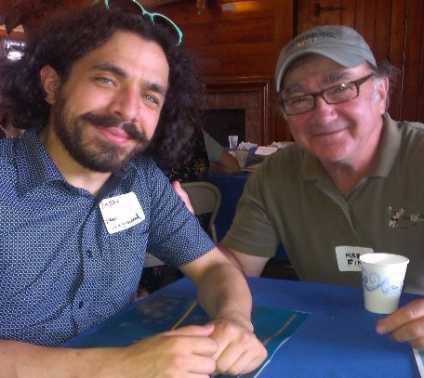

**Bubba Crumrine, Ithaca Underground’s leader (pictured on left)**

**How is it important to this community?** Hear what young participants are saying:

"I discovered IU about 6 years ago as a bored high school student looking for something to do. As a junior at Cornell now, **I am grateful to belong to a community of innovative artists**. I contacted dozens of media companies (for an internship), but no one wanted a teenager with no connections and no experience. IU helped me gain valuable, transferrable skills that I included in reels, resumes, and applications. I've been able to talk about my positive experiences with IU in interviews that helped me earn paid jobs in videography and an internship at Viacom. Capturing music that is at the forefront of counter cultural expression has not only been rewarding, but has also helped me to build my portfolio and develop my artistic eye. **Growing up with Ithaca Underground has enriched my life in so many ways musically, creatively, and socially.**” - Anna W.

"IU jumpstarted my career, getting my name in papers, magazines, blogs, press kits etc. I'm an equestrian photographer, IU challenged me to shoot in very low light, with moving subjects, with big very excited crowds, working around the needs/wants of bands. In January 2016 I traveled to Switzerland to cover the Winter Polo World Cup, in March to Florida for the Gay Polo World Cup, and then the USPA Open of Polo. **You came at a turning point in my life when friends had gone off to college.** IU allowed me to meet friends that I will have for a lifetime." - Maxwell P.

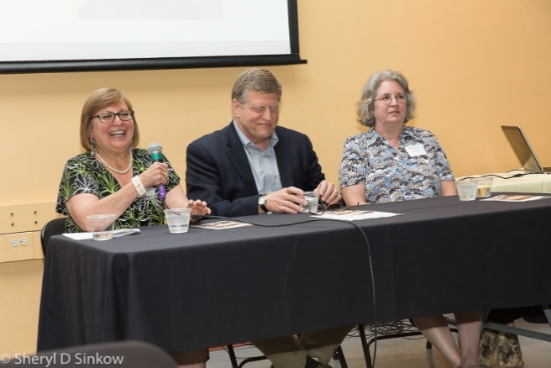

Thank you to our volunteers

From serving on grant review teams, office filing, board service, committee work, and much more; you are ambassadors of community philanthropy.

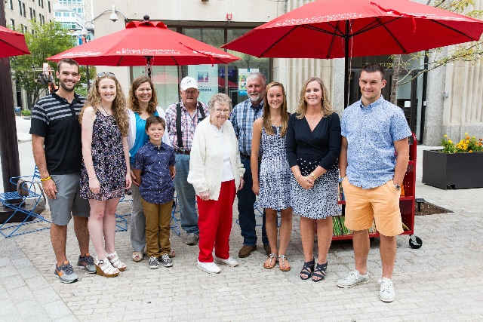

Creative use of space

The outdoor Reading Room on the Ithaca Commons was funded in part by the Hartnett Fund, in memory of former board member and long-time friend, Howard Hartnett.

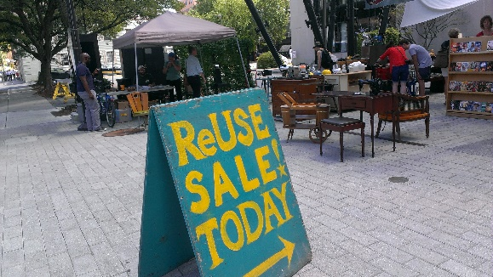Finger Lakes ReUse site visit

Re-Vision: the next phase of ReUse for local spaces, materials, and job training.

*You can get involved with your Community Foundation, call us, or visit www.cftompkins.org*

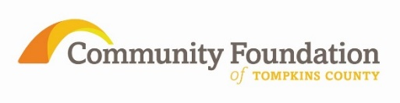

## By The Numbers (6/30/16)

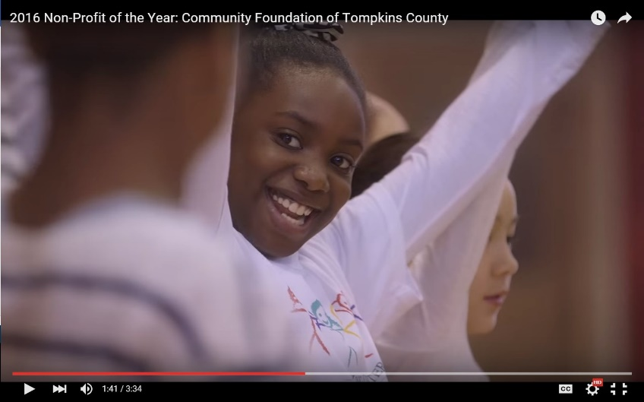

$13.8 Million Assets

$8.5 Million Endowed Funds

$5.3 Million Non-Endowed Funds

Fund Types (99 Funds)

6 Community Impact Funds

9 Field of Interest Funds

23 Designated Funds  
  
61 Donor Advised Funds

2016 Grant Cycles ($ Granted)

$ 32,445 Women’s Fund Grant Cycle

$ 136,315 Library Grant Cycle

$ 101,759 Spring Grant Cycle

$ 7,350 May Letters of Inquiry

### Community Investments

Community Foundation named **2016 Non-Profit of the Year**

by Tompkins County Chamber of Commerce

The Community Foundation enables everyone to be a philanthropist.

|  |  |
| --- | --- |
|  |  |

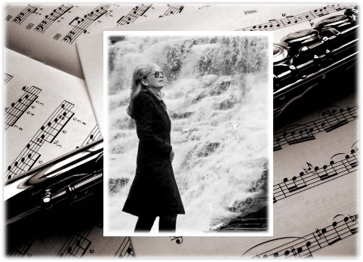

**Continuing the Arc of Life**

Celebrate the lives of loved ones; knowing your gift continues to benefit their communities.

Our newest memorial funds:

Laurie Conrad Music and Arts Fund

The Sophie Fund

Community Memorial Fund

In our 16th year with over $10.5 million in more than 2,500 awards, the Community Foundation is a leading grantmaker in Tompkins County.



I