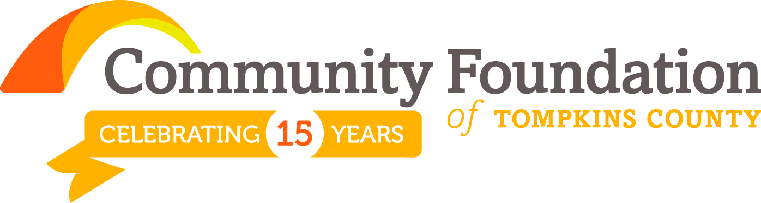
What We Do By the Numbers 4Q 2014
LEARNING TO GIVE GIVING TO LEARN
[Cite your source here.]

The mission of our Community Foundation is to improve the quality of life in Tompkins County by inspiring and supporting enduring philanthropy.

Community Foundation
Grants from inception: Aug. 2000 – Dec. 31, 2014
Total amount Granted: $ 6,646,872
Number of Grants: 1,963

These grants represent the current philanthropic goals and interests of our donors as well as the grant making strategy of the Community Foundation’s Board of Directors.

Community Foundation  Grants (Year 2014) | % of  $ | $ Area  Amount | # of  Grants
Arts & Culture * | 24% | $389,421 | 89
Community Building | 19% | $310,342 | 63
Education | 11% | $174,514 | 31
Environment/Sustainability | 3% | $43,575 | 18
Health & Human Services | 43% | $695,083 | 104
Total |  | $1,612,935 | 305

*Public libraries are included in Arts & Culture. Detail regarding a portion of these grants is provided below.

Bernard & Shirley Rosen Library Fund – 2014 Grants
33 libraries of the Finger Lakes Library System
Total amount Granted: $ 117,265
Number of Grants: 21

Status: 501(c)3 public charity
For additional information, find our latest annual report and financial statements at www.cftompkins.org
or call 607-272-9333

Confirmed in compliance with National Standards
for U.S. Community Foundations.

Assets (12/31/14)

$14.2 million assets
$ 8.0 million endowed assets
$ 6.2 million expendable assets
________________________________________
Return on Portfolio Investments
5.41% 2014 return
18.38% 2013 return
12.05% 3 yr. return (annualized)
10.11% 5 yr. return (annualized)
________________________________________
Gifts Received
 | 2014 | 2013 | 2012
$ | $2.1m | $2.1m | $2.9m
# | 616 | 798 | 488
________________________________________
Fund Types (88 funds)
1 Tompkins Today and Tomorrow Fund
1 Operational Endowment Fund
7 Field of Interest Funds
56 Donor Advised Funds
23 Designated Funds
________________________________________
philanthropy education
Learning Center
Donor Services
Grantee Guidance
Technical Advisor
Community Outreach

Learning to Give, Giving to Learn: inspiring and supporting enduring philanthropy…

Shared knowledge and civic engagement…
At its core, a community foundation is a place of and for learning and civic engagement. ”Its bottom-line mission is to generate local resources for local needs. But it accomplishes that mission not simply by raising money, but also by educating community members - its neighbors – to see and to care, thus empowering them to support causes close to home and close to the heart.” Former member, Tompkins County Funders Group
Joanne Florino ~ Senior Vice President for Public Policy, Philanthropy Roundtable

Changing lives…
A unique training program, ReSET, offers unemployed or underemployed individuals a way to discover the impacts of a disposable consumer culture and the value of, skills required for, and satisfaction resulting from reusing materials. “As our community and consciousness continue to grow and evolve, the value of the materials that are kept out of landfills is becoming more widely recognized. Programs like ReSET help give our community and our stuff new life.”
Community Foundation grantee
Anise Hotchkiss ~ Community Programs Coordinator, Finger Lakes ReUse

Engaging the community...
“Being a student at Cornell means that you are also a part of the broader Ithaca community. Personally, I think that having the opportunity to be at any university means that you have the responsibility to use what you are learning to give back. I love being a volunteer with the Community Foundation because I feel like I am using the skills that I've built at the Johnson School to make a difference. I also feel that being a part of the Community Foundation has enriched my own education, and allowed me to build valuable relationships across a variety of organizations.” Community Foundation Grant Review Team member
Beatina Theopold ~ student, MBA program, Johnson School, Cornell University

Investing in the future...
Community Foundation funding supported the expansion of important financial programs into surrounding towns of Tompkins County reaching low-income, rural tax filers. “We believe in opportunity. For all.” This year, tax returns were prepared and filed for 1,782 clients, bringing a net total of $3.7 million in tax refunds to working families in Tompkins County and to our local economy. “We’re hungry for ways to help with the many social problems that surround us.” Alternatives’ seeks to build wealth and create economic opportunity for the underserved people and communities. Community Foundation grantee
MaryBeth Bunge ~ Development Director, Alternatives Federal Credit Union

Creating community exchange…
The Civic Ensemble is committed to using storytelling to create an environment in which we as a community can examine different points of view without judgment. The notion of engagement is central to all of Civic’s work. “People say ‘Why theater?”” “Theater is unique in its liveness and its potential through that liveness to engage people. Theater engages both
our thinking and our feeling … As a tool for dialogue, theater is unique in its ability to engage people, to catch them off guard. They can be having fun, then turn right around to having a serious conversation.” Community Foundation grantee
Sarah Chalmers ~ Director of Civic Engagement, Civic Ensemble

 | *********************
Philanthropy Learning Exchange (PLEX)  Estate planning questions?  Speaker: Michael May, Esq.  Wednesday, March 4th noon and 5pm  See events at www.cftompkins.org | Communities – what’s happening?  Learn more!  Interactive Mapping:  Community Foundations Atlas  See news at www.cftompkins.org | Celebrate with us!  Share. Honor. Connect.  Women’s Fund Annual Luncheon  Tuesday, March 10th noon -2pm  See events at www.cftompkins.org

