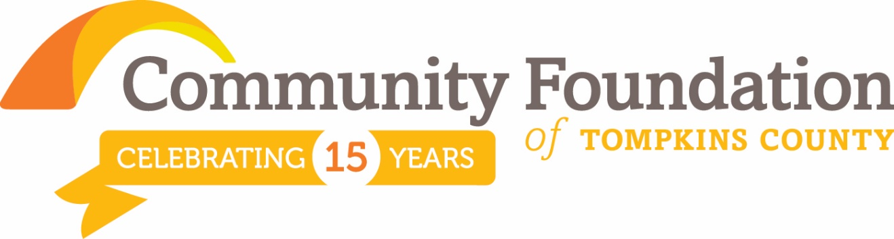
FOR IMMEDIATE RELEASE
For More Information Contact:
George Ferrari, Chief Executive Officer
607-272-9333
gferrari@cftompkins.org

Community Foundation Celebrates Fall Grant Cycle with $115,000 of Grants
ITHACA, NY NOV. 17 - FOR IMMEDIATE RELEASE
The Community Foundation of Tompkins County celebrates its Fall Grant Cycle, Collective Impact: Building Relationships, Building Our Future. This two year cycle resulted in 10 grants totaling $115,000 to 8 organizations serving our community.

Grants Awarded from our Collective Impact Field of Interest Fund based on grant review team recommendations:
- Finger Lakes ReUse: Developing an Effective and Comprehensive Job Training Model
- Center for Transformative Action: Dorothy Cotton Institute-Cradle to Career Initiative
- Cornell Cooperative Extension of Tompkins County: Natural Leaders Initiative – Bringing Collective Impact Home
- Challenge Workforce Solutions: Youth Employment Training Program
- GreenStar Community Projects: Re-shaping the Local Food System

Grants Awarded from other Community Foundation funds based on individual donor advisor philanthropic goals:
- Discovery Trail: Kids Discover the Trail! Program Expansion Planning
- Finger Lakes ReUse: Developing an Effective and Comprehensive Job Training Model
- Suicide Prevention and Crisis Services: Stay in Touch Program: Improving Mental Health Outcomes after Discharge
- Challenge Workforce Solutions: Youth Employment Training Program
- SPCA of Tompkins County Public Assistance for People and their Pets: Helping those in need through a difficult time

Community members are invited to learn more by attending the grant celebration on Monday, December 14 from 6:30-8:00PM at the History Center, 401 E. State/Martin Luther King, Jr. Street, Suite #100.

The 2016 Community Foundation Grant Cycle calendar is now available at http://www.cftompkins.org/granting/grant-opportunities/

Also drop by our Holiday Open House, December 11, from 10:00AM to 2:00PM at 200 E. Buffalo Street, Suite 202.

The Community Foundation is a non-profit public charity created by and for the people of Tompkins County, making grants in 2015 of more than $1.7 million and growing. The organization accepts gifts and bequests. To learn more about the Community Foundation, please contact George Ferrari, Chief Executive Officer, 200 E. Buffalo Street, suite 202, Ithaca, NY 14850 gferrari@cftompkins.org or call 272-9333.

