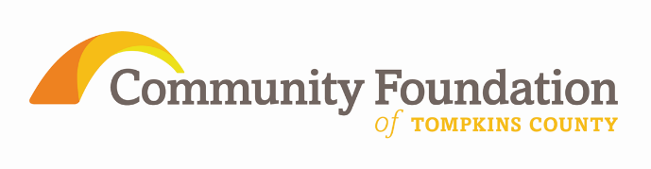
IMPORTANT DATES
- January 15, 2015 - Grant Applications Due
- March, 2015 - Awards announced
- December 16, 2015 – Interim Report Due
- August 25, 2016 – Final Report Due

The Community Foundation of Tompkins County Library Grant Cycle 2015 funded by the Bernard Carl and Shirley Rosen Fund

Guidelines and Application Procedures
The Community Foundation of Tompkins County is offering this grant cycle to the 33 libraries in the Finger Lakes Library System (FLLS).

Grantmaking Objective:
- To promote genuine intellectual curiosity and a lifelong love of reading and learning in youth
- To promote greater and easier access by youth to local libraries

Grantmaking Areas:

- Summer Reading Programs
- Story times
- Youth Engagement
- Other

Grantmaking Guidelines for this grant cycle:
- Only one application per funding area (i.e. summer reading program, story time, youth engagement, etc.) will be accepted.
- Grants must serve youth defined as ages birth-21
- Grant monies may not be used to supplant “existing library revenues”.
- Applications will be accepted for projects previously funded by the Community Foundation.
- The grant range is between $200 and $15,000. (The total of all grants to a single library will not exceed $15,000).
- The grant award must be expended by June 30th, 2016.
- This grant will not fund “Bricks and Mortar”, this includes building materials and anything for the built environment including its furnishings.
- Any grant modifications sought by the grantee to change the time period or program parameters from the approved application must be requested in writing (via e-mail) and receive approval by the Community Foundation.
- A Maximum of three applications per library will be accepted, including applications that are part of a collaborative application.
- Collaborative applications with other libraries are encouraged. One library should take the lead role with the application with Letters of Support from collaborating libraries.
- It is no longer necessary to include the financial section of your NYS annual report (sections 11 & 12) as it can now be accessed by reviewers on the FLLS website.
- Review the document “Lessons Learned and Tips for Strengthening Community Foundation Library Applications” before completing your application.

Application Procedures
- A complete application must be submitted electronically to info@cftompkins.org by 5 pm on the due date. Applications can be found at http://www.cftompkins.org/granting/grant-opportunities/ .
- Applications meeting the requirements will be reviewed by a Community Review Team and recommended to the Donor Advisor of this, and other, funds. Final approval will be made by the Community Foundation Board of Directors.
- Please direct questions about completing your application to the Program Officer, Janet Cotraccia, at jcotraccia@cftompkins.org or (607) 272-9333.
- The signature sheet is required for an application to be considered complete. Due to the required signatures, the application can be submitted in the following methods:
  - Scan the completed document and send it electronically.
  - E-mail the application and fax the signature statement sheet separately.
  - Mail the completed application such that it is received by the due date.

