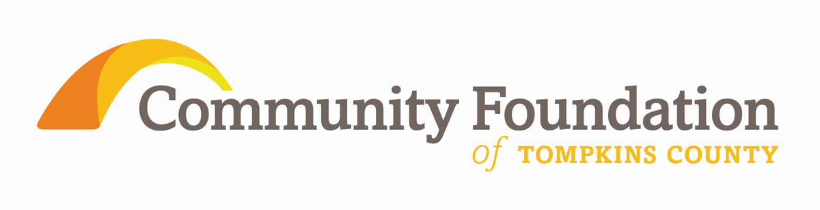

Community Foundation
Listening Learning Partnerships

Please come to the gathering having thought about your responses and reactions to the questions below. We will be collecting your responses in a brainstorming format, aggregating them and sharing trends and themes with the Community Foundation’s board of directors and donor advisors. Individual attributions will not be made unless you have granted us permission to do so. Thank you.

What are two or three of the most pressing current issues for your community?
Which of these issues have emerged within the last year?

Have the current economic conditions led you to think differently about your community’s future than you have in the past?
Are you exploring any alternatives which you might not have considered before now?
Have conditions caused any change in strategic direction? Mission?

What is the most effective grant received that assisted the people of your community? What made it different from others?
If you were to describe the "ideal" grant from the Community Foundation in the next 3 - 6 months, how would it be structured? What would it be for?

To whom does the leadership in your community look for help in difficult times - both for assistance in planning for the future, fundraising ideas, operational assistance?
Are there sufficient resources in the community to assist you? In what ways could the Community Foundation be more helpful?

