MC900429205[1]Monday December 10 from 9:30 to 11:30 AM

Borg Warner Room of

theTompkins County Public Library

101 East Green Street, Ithaca

FREE and OPEN to the public!

No registration is required.

Sponsored by the Human Services Coalition of Tompkins County

**Participating Panelists**:

**Richard Driscoll** *Facilitator*

**Michelle Benedict-Jones** *Senior Vice-president, Tompkins Charitable Gift Fund*

**James A. Brown** *President, United Way of Tompkins County*

**George P. Ferrari, Jr.** *Executive Director, Community Foundation of Tompkins County*

**Joanne Florino** *Executive Director, Triad Foundation*  
**Jon Jensen** *Executive Director, Park Foundation*

**Tom Knipe** *Senior Planner/Tourism Coordinator, Tompkins County*

**Scott C. Russell** *Director of Development, Legacy Foundation*  
**Kara Williams** *Program Manager, Health Foundation for Western and Central NY*

LEARN about **organizational overview,**

**funding opportunities,**

**funding guidelines and timelines,**

**and technical assistance or other value-added opportunities provided to local non-profits!**

**Time wil be available for a Q&A session. If you have**

**specific questions in mind, please 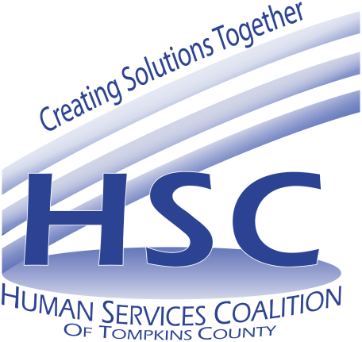Email them to nburston@hsctc.org in advance.**

**(Questions will remain anonymous.)**

**Enter the library at the northeast corner of the building**

**opposite the bus shelter. Go through the door under the green**

**canopy. The Borg Warner Room is immediately on your right.**