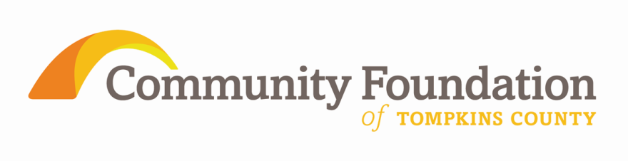
2013 Pledge Form
Community Sustainer/Benefactor/Sponsor/Supporter
These gifts are one important source of support for the Community Foundation’s grant making and operating needs in service to our community. If you wish to support the Community Foundation in this important way, please complete this form with level of support and payment form indicated and return it to The Community Foundation of Tompkins County, 309 N. Aurora St, Ithaca, NY 14850.

- Community Sustainers pledge to give $2,000 annually for three consecutive years.
- Community Benefactors pledge to give $1,000 annually for three consecutive years.
- Community Sponsors pledge to give $500 annually for three consecutive years.
- Community Supporters pledge to give $250 annually for three consecutive years.

(Choose One)
___ I pledge to make annually gifts at the Sustainer level of $2,000 in 2013, 2014 & 2015.

___ I pledge to make annually gifts at the Benefactor level of $1,000 in 2013, 2014 & 2015.

___ I pledge to make annually gifts at the Sponsor level of $500 in 2013, 2014 & 2015.

___ I pledge to make annually gifts at the Supporter level of $250 in 2013, 2014 & 2015.

(Choose One)
___ Enclosed, please find my gift for 2013. Checks should be written to: Community Foundation of Tompkins County. Please note on the memo line “Community Sustainer, Benefactor, Sponsor or Supporter 2013.”

___ I would like to pay by credit card (See reverse side.)

Community Sustainers, Benefactors, Sponsors and Supporters will be acknowledged in the Community Foundation’s Annual Report, on our Website, and in other publications. Please indicate your permission for us to use your name in these ways.

___ I/We agree to allow the Community Foundation to mention my/our name(s) as
Community Sustainer, Benefactor, Sponsor or Supporter.

When being listed, I/we wish to be listed as:
_________________________________________________________________________

___ Request for Anonymity: By checking this line you will not be publicly acknowledged.

__________________________________________________________________________
Donor’s Signature Date (note: your 2nd and 3rd pledge payments will
be expected by this date in 2014 & 2015.)

__________________________________________________________________________
Donor Name Phone Number

__________________________________________________________________________
Donor Address
All gifts are tax-deductible.

Gifts made by credit card will be processed upon receipt of this form. Your card will be charged annually on this date (2013, 2014 & 2015) unless the Foundation is told to do otherwise. Keep in mind that 4.5% of your credit card gift applies to processing fees. To avoid these fees, you may prefer to send a check.

Credit Card Information:

Card Name (please circle): VISA MasterCard American Express

Name as shown on card (please print):___________________________________________

Account/Card #_____________________________________Expiration Date____________

Authorized Signature_______________________________________ Security Code______

Email address_______________________________________________________________
(required for credit card charge)

