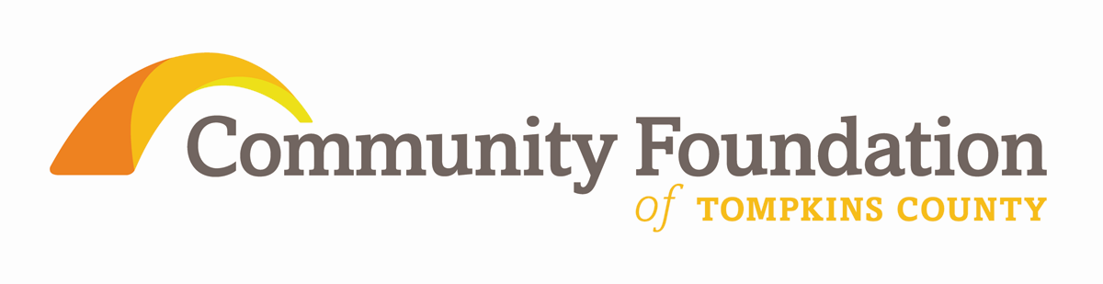

Pride of Place, 2009 - 2012
Executive Summary of A Listening & Learning Report
from the Community Foundation of Tompkins County

The rural towns of Tompkins County:
Caroline, Danby, Dryden, Enfield, Groton, Lansing, Newfield, Ulysses

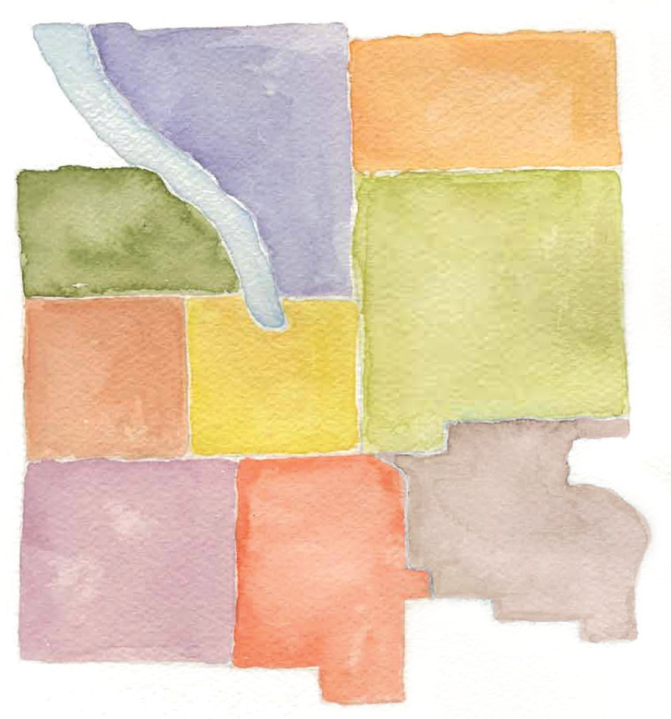

Listening to our neighbors and learning from them is a vital part of the mission of the Community Foundation of Tompkins County. Beginning in 2009, members of the Foundation’s Board of Directors and staff conducted eight conversations with residents from each of the rural towns of the County to ask for insights about the issues that were of greatest importance.

From the nearly 20 hours of conversations, the Community Foundation has compiled a summary to guide our grant making work. This summary is also intended for others to study and learn about the realities of life and pressing needs within the rural towns of Tompkins County. As important, the lessons learned will help guide political and economic leaders and individual donors toward assisting these townships to find paths to ensure the connections they value, preserve the quality of life they want, and the means to secure their towns’ future.

KEY THEMES
Rural residents expressed the desire to preserve current rural ways of life and values with the need to adopt new strategies to provide opportunity for growth in an uncertain future and with unprecedented economic challenges.

During the timeframe of the Listening & Learning sessions, State and Federal funding cuts for important programs were followed by County funding cuts and the NYS property tax cap, all of which have reduced town resources and staff.

There are striking similarities and significant differences across the 8 rural towns of Tompkins County:
- Residents are eager to share their values, their assets, their challenges, and opportunities for partnering with the Community Foundation.
- Some towns have important internal rural-suburban divisions.
- Community Councils are important assets as are local town and village elected officials.
- Some towns have their own county legislature representative. Others share legislators with other towns making expressing their unique town voice at the county level more complex.

Five major issues emerged from this study: Connection and Pride, Economic Opportunity, Land and Water, Caring for our Neighbors, and Concerns about the Future. For greater detail, please order free copies of “Pride of Place” from Community Foundation of Tompkins County, 309 North Aurora Street, Ithaca NY 14850
607 272 9333

Lessons Learned, Actions Ahead

The lessons from this report can vary widely. A resident of one of the towns can draw reassurance that there is a family of issues that is shared by residents of rural communities. To a resident of relatively more urban areas of the community, there is a strong reminder that rural populations are uniquely at risk, though particularly resilient, in terms of health care, environmental issues, and economic opportunities. To planners, public policy makers, and those with philanthropic interests, there is the message of nearby need that thoughtful and careful responses can secure and sustain the futures of all.

Your Community Foundation of Tompkins County is a strategic resource for addressing solutions together with all those who are interested. To be part of enabling the lessons of our Listening & Learning program, please contact:
George Ferrari, Executive Director,
Community Foundation of Tompkins County, 309North Aurora Street Ithaca NY 14850
607 272 9333
www.cftompkins.org

