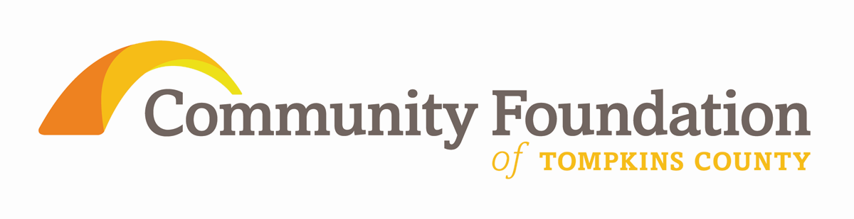

Pride of Place, 2009 - 2012
A Listening & Learning Report
from the Community Foundation of Tompkins County

The rural towns of Tompkins County:
Caroline, Danby, Dryden, Enfield, Groton, Lansing, Newfield, Ulysses

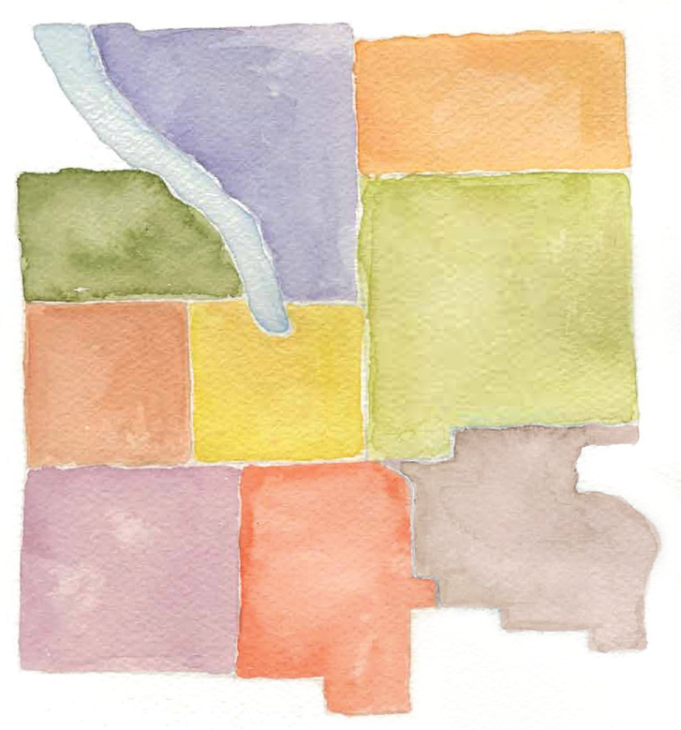

Listening to our neighbors and learning from them is a vital part of the mission of the Community Foundation of Tompkins County. Beginning in 2009, members of the Foundation’s Board of Directors and staff conducted eight conversations with residents from each of the rural towns of the County to ask for insights about the issues that were of greatest importance.

From the nearly 20 hours of conversations, the Community Foundation has compiled a summary to guide our grant-making work. This summary is also intended for others to study and learn about the realities of life and pressing needs within the rural towns of Tompkins County. As important, the lessons learned will help guide political and economic leaders and individual donors toward assisting these townships to find paths to ensure the connections they value, preserve the quality of life they want, and the means to secure their towns’ future.

KEY THEMES
Rural residents expressed the desire to preserve current rural ways of life and values with the need to adopt new strategies to provide opportunity for growth in an uncertain future and with unprecedented economic challenges.

During the timeframe of the Listening & Learning sessions, State and Federal funding cuts for important programs were followed by County funding cuts and the NYS property tax cap, all of which have reduced town resources and staff.

There are striking similarities and significant differences across the 8 rural towns of Tompkins County:
- Residents are eager to share their values, their assets, their challenges, and opportunities for partnering with the Community Foundation.
- Some towns have important internal rural-suburban divisions.
- Community Councils are important assets as are local town and village elected officials.
- Some towns have their own county legislature representative. Others share legislators with other towns making expressing their unique town voice at the county level more complex.

FIVE MAJOR ISSUES: Connection and Pride, Economic Opportunity, Land and Water, Caring for Neighbors, and The Future

- Connection and Pride

There is a strong sense of pride and specific town identity in each of the eight rural towns of Tompkins County.

The town residents’ levels of creativity, collaboration, and volunteerism are commendable and valuable social capital assets.

Sharing of resources, equipment, buildings and service delivery responsibility across town lines and within towns between government and schools was expressed as an important future opportunity.

Thinking more regionally beyond Tompkins County borders, for example Dryden and Groton with Cortland County, may have strong positive new results.

Many town residents are more likely to respond to a request to volunteer rather than accept an increase in taxes. Town residents know who they are; they know when something is a success. Success is celebrated.

In towns without a clear physical center or village downtown, such as Caroline, Danby, Enfield, and Lansing there is a strong desire to develop more visible, publicly accessible common gathering places such as a park or town center.

In towns with historically identifiable village centers such as Dryden, Groton, Newfield and Ulysses there is a focus on preserving and growing existing areas to continue services such as a pharmacy or a grocery store since most residents relate much more to their respective village centers than to Ithaca.

All towns expressed the importance of a building which could be used for a multipurpose variety of community events. Some towns have this asset, many others need it or want to improve or upgrade what they currently use for this purpose.

All towns lamented the scarcity of public transit options and consequent lack of flexibility to plan for alternate, public transportation. Participants mentioned walking paths, bike paths, and sidewalk expansion as important means of building connections in the community.

Many talked about the need to make internet connectivity more universally accessible.

Some saw a need to improve communication among various groups about what is going on within the town.

- Economic Opportunity

There was a universal concern about the growth of employment opportunities for all, especially for youth, in terms of training and retention of young families. This was often expressed along with a need for more affordable housing. Similarly, concern was expressed about the aged housing stock in need of repairs, energy conservation improvements, and removal of lead paint.

Residents are worried about young people permanently leaving, and the implications of that pattern on volunteer-dependent activities such as food pantries and the firefighting and EMT services.

3--Land and Water
Planning for the use of natural resources happens primarily at the town level. Commenters cited the need for land use plans that balance preservation of natural resources, such as water, with economic development opportunity.

There was also concern with the variable quality of well water.

Each town takes an independent approach to the issue of hydrofracking of the Marcellus Shale formation. The views vary from bans and moratoria to a more welcoming position. The participants recognized that the divisiveness and conflicts about hydrofracking put pressure on the schedules of the towns’ staff and divert money from usual town business.

Some but not all of the towns expressed a need for sewer expansion.

4—Caring for Neighbors

Representatives from each town are concerned about how to provide for residents’ food and shelter, such as heating expenses. There is also a desire to promote healthful nutrition and exercise habits.

Other food-related issues include increasing Community Supported Agriculture, food stamp utilization, and senior nutrition.

The cost and ease of transportation affects many town residents. This is especially true because the City of Ithaca is the home to key support services, through which residents can receive eligibility determination and general access, yet many town residents forgo signing up for assistance even though they would qualify and benefit.

5--The Future
The role of a school district and a school building along with split school district enrollment within a town were discussed.

Towns such as Dryden, Groton, Lansing, Newfield, and Ulysses with an indigenous school district expressed a strong sense of pride.

Participants of those towns are also concerned about the tax resources needed to maintain independent districts with a resulting concern being undesired consolidations.

In contrast, Enfield residents send their children to four different school districts. Caroline residents, as part of the Ithaca City School District, see students heading home to a number of other places far away from the building which makes after school activities and transportation challenging. One town, Danby, has neither a school building nor a library.

Public libraries in Dryden, Groton, Lansing, Newfield, and Ulysses are important. These facilities are currently over-used resources that could benefit from expanded hours and programs to serve more residents.

General loss of governmental support for youth programming was mentioned along with a sense that the lower level of support is the new normal.

Other concerns include energy use and alternatives to fossil fuels such as biomass and wind power.

Lessons Learned, Actions Ahead
Depending on one’s perspective, the lessons from this report can vary widely. A resident of one of these towns can draw reassurance that there is a family of issues that is shared by residents of rural communities. To the resident of more urban areas of the community, there is a strong reminder that rural populations are uniquely at risk, though particularly resilient, in terms of health care, environmental issues, and economic opportunities.. To planners, public policy makers, and those with philanthropic interests, there is the message of nearby need that thoughtful and careful responses can secure and sustain the futures of all.

Your Community Foundation of Tompkins County is a strategic resource to address solutions together with all those who are interested. To be part of making possible the lessons of our Listening & Learning program, please contact:
George Ferrari, Executive Director,
Community Foundation of Tompkins County, 309North Aurora Street Ithaca NY 14850
607 272 9333
www.cftompkins.org

