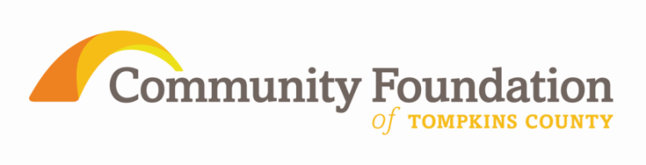

FOR IMMEDIATE RELEASE
For More Information Contact:
Janet Cotraccia, Program Officer
607-272-9333
jcotraccia@communityfoundationoftc.org

Community Foundation of Tompkins County announces 2012 Howland & Community Foundation Grants
ITHACA, NY June 6 - FOR IMMEDIATE RELEASE

Community Foundation of Tompkins County is pleased to announce 12 grants totaling nearly $48,000 of 2012 Helen Thomas Howland Foundation awards to benefit Tompkins and Broome counties. Community Foundation donor advisors or field of interest funds awarded 14 more grants of an additional $39,668 from the resources of the Community Foundation.

As administrative agent for the Howland Foundation, the Community Foundation of Tompkins County reviews all applications and makes funding recommendations to the Howland Foundation trustees. The Howland Foundation supports grants in aging services, youth services, animal welfare, and the environment. Grants are limited to qualified nonprofit organizations that provide substantial benefit to these areas.
The 2012 Howland Foundation grant recipient for aging services is Cancer Resource Center for the seniors’ emergency fund.
The 2012 grant recipients for youth services are Village at Ithaca for the family advocacy program, Beverly J. Martin School for the whole foods cooking program, Alcohol & Drug Council for the at-risk youth support group, Running 2 Places for the accessibility project, and Community Dispute and Resolution Center for the child care provider training.
The 2012 grant recipients for animal welfare are the SPCA for the healthy cats happy homes project and the Broome County Humane Society for feline cages.
The 2012 grant recipients for environmental preservation are WSKG for Frack You!, Cayuga Lake Watershed Network for hydrilla community education, and the Nature Conservancy for the Eldridge wilderness project.
One Howland grant to Family & Children’s Service of Ithaca for their grandparents raising grandchildren program, represents a creative way of seeking results in multiple priority areas by combining goals in youth and aging services.
Community Foundation donor advised grants are awarded to OAR for the aging client fund, to Family & Children’s Service of Ithaca for their grandparents raising grandchildren program, to Finger Lakes Land Trust for the Emerald Necklace, to Beechtree Care center for rehabilitation upgrades, to Village at Ithaca for family advocacy program, to Cancer Resource Center for seniors emergency fund, to Tompkins County Youth Services Department for Groton teen jobs program and for Lansing high school helper program, to Center for Environmental Sustainability for a special needs senior day camp, to Sustainable Tompkins for the Finger Lakes energy challenge, to Drop In Children’s Center for program improvement and to Newfield Public Library for college application assistance for rural youth.
The Community Foundation Children & Youth Fund awarded a grant to Cornell Cooperative Extension of Tompkins County for a Freeville 4H student support program.
All grants will be presented at a special awards ceremony 6:30pm on June 11th 2012 at the Groton Public Library, 112 E. Cortland Street, Groton. The public is warmly encouraged to attend.
Since its inception in 2000 the Community Foundation has facilitated more than $3.6 million in investments in the Tompkins County community from over 1,250 individual grants. Information about the mission and operations of the Community Foundation, and guidance regarding how to invest in the community as a Foundation donor, is available at www.cftompkins.org.

