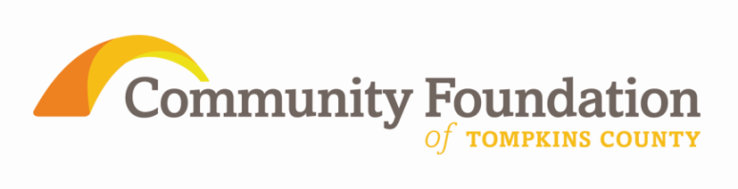

FOR IMMEDIATE RELEASE
For More Information Contact:
Janet Cotraccia, Program Officer
607-272-9333
jcotraccia@communityfoundationoftc.org

Community Foundation of Tompkins County announces Howland & Community Foundation Grants
ITHACA, NY June 6 - FOR IMMEDIATE RELEASE

The Community Foundation of Tompkins County is pleased to announce 13 grants totaling over $52,000 of 2011 Helen Thomas Howland Foundation awards to benefit Tompkins and Broome counties. Seven additional requests were selected by Community Foundation donor advisors or field of interest funds for grants of an additional $25,000 from the resources of the Community Foundation.

As administrative agent for the Howland Foundation, the Community Foundation of Tompkins County reviews all applications and makes funding recommendations to the Howland Foundation trustees. The Howland Foundation supports grants in aging services, youth services, animal welfare, and the environment. Grants are limited to qualified nonprofit organizations that provide substantial benefit to these areas.
The 2011 Howland Foundation grant recipients for aging services are Lifelong for a Newfield fitness program, and the Kitchen Theatre for a senior ticket initiative.
The 2011 grant recipients for youth services are Franziska Racker Centers for their capital campaign, Advocacy Center for shelter improvements, Hangar Theatre for work in 4th grades of Newfield Schools, Cooperative Extension for a youth energy leadership project, Tompkins Community Action for a youth job training program, and Groton Public Library for an art project.
The 2011 grant recipients for animal welfare are the SPCA for their annex and the Broome County Humane Society for feline cages.
Three Howland grants represent creative ways of seeking results in multiple priority areas by combining goals in youth and environment priorities. They include Finger Lakes ReUse for an apprenticeship program, Village at Ithaca for Ithaca Community Harvest and Southern Tier Advocacy & Mitigation (STAMP) for a youth media collective.
Community Foundation donor advised grants are awarded to the Finger Lakes Land Trust for land acquisition, STAMP for a youth media collective, Habitat for Humanity for a youth work group, Brooktondale Community Center for the Caroline Farmers Market, and Child Development Council for a rural transportation project. The Community Foundation’s Children and Youth field of interest fund made grants to Planned Parenthood of the Southern Finger Lakes for an LGBT youth group as well as to STAMP.
All grants will be presented at a special awards ceremony 6:30pm on June 13th 2011 at the Ulysses Philomathic Library, 74 E. Main Street, Trumansburg. The public is warmly encouraged to attend.
Since its inception in 2000 the Community Foundation has facilitated more than $3.1 million in investments in the Tompkins County community from over 1,095 individual grants. Information about the mission and operations of the Community Foundation, and guidance regarding how to invest in the community as a Foundation donor, is available at www.cftompkins.org.

