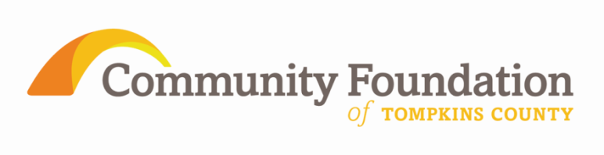
IMPORTANT DATES
- Wednesday, Sept. 18, 2013–Grant Applications Due
- Late Nov. – Final Notification
- Sept. 18th, 2014 - Interim reports due
- Dec. 31, 2015 – Final Report due
2 Year Grants, Magnified Results - Fall, 2013
Guidelines and Application Procedures

The Community Foundation of Tompkins County is offering a two year (payout in 2013 and 2014) Grant Cycle to assist community organizations in achieving increased effectiveness. This grant cycle continues the Community Foundation’s commitment to respond to what was learned during the “Listening and Learning” sessions carried out throughout Tompkins County in 2013. We welcome applications for programs/projects that would benefit from a two year funding cycle.

Grantmaking Goals:
- Strengthen Assets: To preserve and strengthen programs in Tompkins County.
- Greater Resources: To increase resources available to organizations, which will aid in the ability to provide services and/or programs.
- Greater Efficiency: To improve the utilization of resources within organizations resulting in improved efficiency.
- Greater Effectiveness: To improve the management and allocation of resources within organizations resulting in successful programs.

Grantmaking Areas:
This grant cycle will make two year grants available to address the above goals. Grants will support the following initiatives:
- Support for a program or project with demonstrable outcomes.
- Capacity Building (i.e. planning activities, board/staff development, software purchases and training, mergers and collaborations)

Grantmaking Guidelines:
- Grant applications need to address at least one of the above identified areas.
- Grant applications will not be accepted for Capital Campaigns.
- Up to 20% of the requested amount can be used for operating support.
- Grant applications must clearly describe how the program/project would benefit from a two year funding cycle and include a timeline marking projected milestones.
- Grant requests between $2000 - $10,000 will be considered. Requested amounts are the total amount to be granted over a two year period. (Half of grant award to be granted out in 2013 and half in 2014).
- The grant award must be used by November 2, 2015 with an interim report submitted by September 18, 2014 and a final report submitted by December 31, 2015.
- The second year’s grant portion will be released contingent on review of the interim report.
- Requests for budget/program modifications should be included with the interim report.
- Acceptance of a grant award indicates willingness to host a site visit by one or more Community Foundation representatives during the grant period.
- Please contact the Community Foundation for information about collaborative applications involving two or more organizations or if your organization uses a fiscal sponsor.
- Eligible applicants must be located in Tompkins County and provide services for a charitable purpose to residents of Tompkins County. Applicants must also be one of the following:
  - 501(c)3, not-for-profit organization
  - Government (e.g. schools, municipality)
  - religious organization (to support non-religious activities directed toward a public purpose)
- There will be an informational meeting about this grant cycle from 2-3PM on Thursday, September 10th at Cooperative Extension, Rm. A. This meeting is not required, but will be an opportunity to ask questions about the application and grant cycle.
- Please direct questions about completing your application to Janet Cotraccia, Program Officer, at jcotraccia@cftompkins.org or (607) 272-9333.
- A complete application must be submitted electronically to info@cftompkins.org by 5 pm on Wednesday, September 18th, 2013. Applications can be found at www.cftompkins.org. Late applications will not be accepted. The signature sheet is required for an application to be considered complete.
- Applications meeting the requirements will be assessed by a review team with final approval by the Board of Directors. Awards will be announced in late November, 2013.

