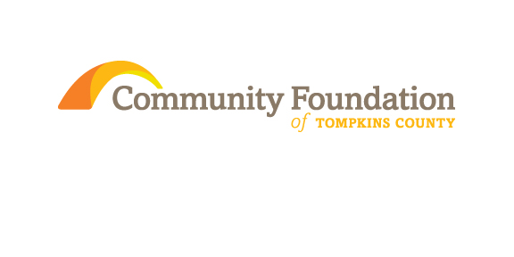
Listening Learning Sessions 2013
- Operating Grants:
- How to create a compelling proposal for this type of need?
- Focus on identifying need and impact of organization to justify this type of grant
- Useful and important grants for all organization no matter their “age”.
- Open-ended support is hard to justify

- Capacity Building Grants: The needs
- Opportunities to develop effective Strategic Plans
- Developing more “Leading with Impact” sessions
- Opportunities to assess programs/whole organization/technology
- Providing more board education for knowledgeable and effective board members
- Creating staff that can do many jobs
- Technology and equipment sharing for all non-profits

- Programming Grants:
- More support for existing programming
- Start up to try a new idea where outcome is unclear.
- $ for planning can be helpful.
- Collaborative grants that foster doing something in a new way.

- Capital Grants:
- Need to generate excitement around infrastructure
- Lots of organization doing Capital Campaigns currently
- Capital grants refer to something extraordinary beyond a typical annual operating budget and may refer to a building project, equipment, endowment building or other items
Overall Concerns:
- Requirements of the Grant:
- Too many restrictions make it challenging to reach impact desired
- Find themselves micro-managed
- Money and the Project
- Partial Funding can be difficult if don’t have other avenues for revenue.
- Short funding cycles makes it challenging to assess impact
- More funding of administrative activities
- Providing adequate salaries for staff to live on
- Education on Grantwriting
- Always important to learn more about the insights of grantwriting and creating a successful proposal
- Inter-organizational Grantmaking
i. Some interest in Community Foundation defining a priority or sector wide issue and inviting applications from multiple organizations to work together and cross organizational silos, for instance what community foundations have done in Elmira and Rochester for early child school readiness, could be for any issue in Tompkins such as food programs, youth employment, or mental health
ii. Grants could for planning as well as for implementation
- Hate to see CFTC limit number of grants that can be submitted by a single organization. Preparing grant applications is often a great way for program managers to get much much clearer about what their program is and what it is meant to accomplish. It helps to develop better programs by increasing clarity and focus.
- Reduction of funding opportunities through government organizations
- Lack of government funding and uncertainties on those opportunities has non-for-profits looking to private funding for replacement funding.
- How to reach the untapped capital in the community as reported by the wealth transfer study
Opportunities for the future:
- Multi-year grants:
- Allows more time to make a program successful; increases ability to evaluate and assess program and develop strategies for improving.
- Makes budgeting easier
- Gives time to leverage the grant for additional money from other sources
- Allows time to evaluate results and impact and to make appropriate adjustments
- Several folks thought a smaller amount per year but spread out over time would be helpful

- Grant education: “ What exactly does the donor want to see?”
- More explicit explanations on portions of grant applications such as collaboration and how it’s defined by the granting organization
- What are the priorities of the funding organization and how can a nonprofit align its cause to the funding opportunity.
- Defining success and address how impact will be evaluated
- Multi-agency Grants
i. Award grants to a temporary joint effort of more than one agency to come together to achieve the impact that no one agency could do on its own
- Longer grant cycles:
- 15 to 18 months following the award

