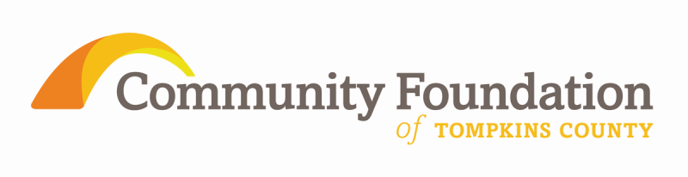

Bernard Carl and Shirley Rosen Library Fund

Final Report Guidelines

Interim/Final Report Guidelines
- Interim Report (due December 31, 2014)
- Final Report (due August 26, 2015)

The Community Foundation of Tompkins County is pleased to have made a grant to your library and looks forward to receiving a summary of your project’s progress. This information is valuable in helping the foundation learn about the grant’s effectiveness and is used in guiding future community investments.

SECTION A

Name of Library:
Library Address:
Library Director:
Project/Program Name:
Grant Amount:
Contact Person:
Contact Person Title:
Email:
Phone:

Report of Grant Activities

- Provide a two sentence summary of how grant funds were used:

- Objectives/Outcomes (Use as much space as needed to answer the following questions).

- What was your goal for this project/program (from your initial application)?

- Did you achieve the objectives listed in the original application? Please explain.

- How did you measure your success in relation to your objectives?

- What were your project/program outcomes? Did these differ from your original proposal? Please explain.

- Based on the project/program outcomes, do you feel that the project/program was successful? Please explain.

- What have you learned (e.g. about effective program strategies, realistic outcomes, on-going value of the project, benefits vs. challenges)?

- If you were to repeat this project, what would you do differently?

- If this is your final report, was the entire grant amount used?
Yes______ No________

If no, please return the unused funds to the Community Foundation of Tompkins County within 60 days of this final report. Expected date of the return of unused funds:__________

- Is this an ongoing program or activity? Yes _____ No_____

If yes, how will funding be secured for continuation?

- Please provide any additional feedback on how this grant cycle could be more effective to:
- To promote genuine intellectual curiosity and a lifelong love of reading and learning in youth
- To promote greater and easier access by youth to local libraries

- How was the Community Foundation of Tompkins County publicized?
(Please attach copies of press releases, printed materials, posters, printed programs, etc. or give information about television or radio interviews)

- Media Tools: Please email 1-4 digital photographs of the project to: info@cftompkins.org If unavailable, please explain:

#3 Program/Project Budget Sheet
Use this Financial Report form to compare your original budget with actual figures. Please explain any variations from your original budget.

REVENUE
Total Anticipated Support/Revenue

Amount received in this grant:
- Government (grants, contracts)
  - City
  - County
  - State
  - Federal
  - School & Tax District
- United Way
- Membership
- Program Service Fees
- Other (Please Specify)
Total Support/Revenue

EXPENSES
 | Total Expenses of Project/Program | Expenses Covered By Requested Grant
- Professional Salaries
- Support Staff Salaries
- Employee Benefits
- Purchased Services (inc. contracted services)
- Collection Expenditures:
  - Print (books, magazines, newspapers, graphic novels)
  - electronic (downloadable titles, databases)
  - other (audio books, playaways, etc.)
- Telecommunications (i.e. phone, fax, etc.)
- Supplies & Materials
- Indirect Cost
- Travel and meetings
- Equipment
- Miscellaneous expenses (describe)
Total Expenses

Surplus (Deficit)

Note: Failure to submit these reports by their due dates may affect your library’s eligibility to receive future grants.

