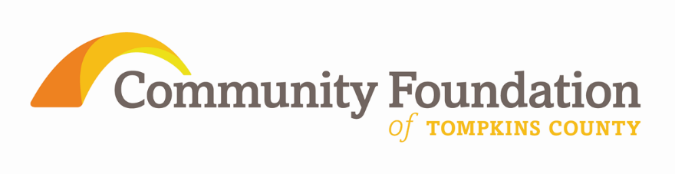

Position Title: Chief Development Officer (CDO)
Immediate Supervisor: Chief Executive Officer
Status & Hours: Fulltime, exempt with some off-site work with attendance at occasional evening and weekend activities

Context and Rationale: The Community Foundation seeks an ambitious seasoned professional who can meaningfully contribute to its aggressive growth goals to diversify programmatic revenue, to increase funds for discretionary grant making and to grow current and new donor advised and field of interest fund assets.

This position has primary responsibility to increase the Community Foundation’s charitable and operational resources. This position has responsibility to draft, modify and evaluate the Community Foundation’s first ever strategic fund development plan including setting goals. This position is responsible for asset development for operations as well as growth in donations to all types of funds: donor advised funds, field of interest funds and designated. This position has substantial solicitation responsibilities.

Primary Role: To provide the highest quality and most effective asset growth plan and practices that facilitate increased charitable assets and expanded recognition of the Community Foundation’s role in local philanthropy. To serve as the primary staff person for the Foundation’s development activities including but not limited to annual gifts, major gifts, corporate underwriting, and planned gifts and to play a role in soliciting gifts in each of these areas. To identify and to manage a portfolio of the top donors and prospects.

The CDO will work with the Chief Executive Officer and the Board of Directors to establish dollar and donor goals within an annual plan coordinated with the strategic development plan. The CDO’s annual plan will include portfolio management for major gifts and planned gifts. The CDO provides primary staffing to the Development and Community Relations Committee specifically and with all members of the board of directors in general to effectively support them in their development responsibilities.

Prioritization of Duties

Development Planning
- Develops, promotes, delivers and evaluates an annual comprehensive development plan focused on annual growth and aligned to the current strategic plan with specific and measureable goals including volunteer solicitor support and top prospect portfolio management
- Creates short and long term goals for new gifts for existing funds, for new funds, for unrestricted operations, and discretionary grant making including endowed gifts into all of the above type funds
- Plans and executes an effective strategy for growing Legacy Society, field of interest fund, giving societies, and unrestricted giving including, but not limited to, HEROES Circle
- Provides information and guidance to enhance and coordinate the Chief Executive Officer’s involvement with and solicitation of donors and prospects

Solicitation
- Meets or exceeds annual fundraising goals adopted in consultation with the Board of Directors and the Chief Executive Officer
- Makes a specific number of current donor and prospect solicitations each month
- Develops and executes a new corporate underwriting solicitation program
- Expands relationships with professional advisors to increase planned gifts
- Manages annual giving program
- Manages major gifts program
- Creates customized solicitation strategies for all major donors
- Identifies, cultivates, solicits and manages a portfolio of top prospects and donors to secure major current use and major endowment gifts
- Expands, diversifies and upgrades the Foundation’s donor base by building a pipeline of prospects to secure endowment and unrestricted operations gifts
- Plans, prepares and executes all collateral materials such as appeal letters, case statements, major gift proposals, donor reports and briefing materials
- Creates and executes outstanding creative recognition/thank you strategies

Documentation and Research
- Oversees data entry, maintenance and reporting from donor/prospect database
- Researches donors and prospects for potential, inclination and ability to give
- Stays abreast of national and local donor and community foundation trends, shares with board and staff and adjusts plans accordingly
- Conducts ongoing analysis of fund development program to develop strategies to increase giving and participation
- Reviews and updates development dashboards and reports for internal analysis

Volunteer Engagement
- Supports, engages, trains, recognizes and appreciates volunteers and board members in their development work including prospect identification, individual asking plans, referrals and solicitation
- Trains board members in all aspects of their development responsibilities

Qualifications and Expectations:

Professional/Technical Abilities:
- Demonstrated ability to effectively organize and prioritize multiple, simultaneous work assignments and meet deadlines
- Demonstrated paid professional work of at least 5-7 years in leadership development staff positions
- Demonstrated experience in initiating new development plans in philanthropic institutions, especially young or small community foundations or community based nonprofit agency
- Highest degree of customer service skills, anticipating needs of donors, positive problem solving orientation, and planning skills
- Ability to establish and maintain effective working relations with donors, prospective donors, and volunteer solicitors.
- Ability to work effectively with a diversity of people and styles
- Excellent written and oral communication skills
- Ability and willingness to maintain the highest standards of confidentiality and development professional ethics including donor bill of rights
- Competency with computer programs including Microsoft Office Suites, internet research, experience maintaining foundation database and information management systems
- Able to work both independently and collaboratively

Qualifications & Experience:
- BA or BS degree
- Development employment experience of at least 7-10 years
- Demonstrated competency and direct personal leadership in successful community based development
- Demonstrated success in establishing and managing relationships and successfully soliciting and closing major gifts and corporate sponsorships.
- Experience in all aspects of development communications including the ability to write clearly, persuasively and powerfully
- Training in nonprofit or foundation functions
- Success in techniques and strategies for annual gifts, major gifts, planned gifts and corporate underwriting
- Demonstrated success in recruiting, training, supporting and recognizing development volunteers
- Experience in and/or willing to learn about all aspects of development including prospect rating, annual appeals, major gifts, planned gifts, campaigns and donor stewardship

Personal Characteristics:
- Commitment to serve the community and to the mission of the Community Foundation
- Ability to identify and to earn the trust of high net worth individuals in respectful, confidential and honorable manner, to quickly establish credibility
- Engaging personality, warmth, empathy, courteous and diplomatic
- Professional image, positive, upbeat and enthusiastic
- Persuasive, motivating, discerning, curious, open and focused
- Creative and entrepreneurial, willingness to embrace new approaches
- Good judgment and decision making abilities within competing priorities
- Self-starter, ability to work independently, intrinsically motivated
- Thinks independently and creatively
- Detail-oriented
- Personal integrity, commitment to confidentiality and discretion
- Excellent written, verbal, and presentation skills

Community Foundation is an Equal Opportunity Employer
Reasonable accommodations may be made to enable individuals
with disabilities to perform the essential functions

