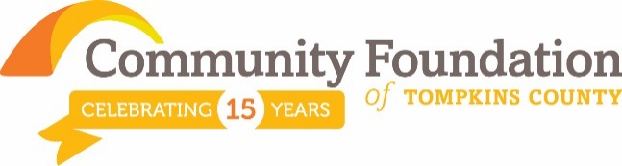
What We Do By the Numbers 3Q 2015
Creating Community Connections
[Cite your source here.]

Our mission:
“improve the quality of life in Tompkins County
by inspiring and supporting enduring philanthropy”

Community Foundation
Grants from inception: Aug. 2000 – Sept. 30, 2015
Total amount Granted: $ 8,189,509
Number of Grants: 2,204

These grants represent the current philanthropic goals and interests of our donors as well as the grant making strategy of the Community Foundation’s Board of Directors.

Community Foundation  Grants (year-to-date 2015) | % of  $ | $ Area  Amount | # of  Grants
Arts & Culture | 19% | $294,985 | 69
Community Building | 19% | $298,033 | 46
Education | 8% | $128,224 | 31
Environment/Sustainability | 6% | $88,250 | 13
Health & Human Services | 48% | $733,145 | 82
Total |  | $1,542,637 | 241

Eligible organizations may apply in 4 competitive cycles or general Letter of Inquiry (LOI) processes, each with specific grant priorities. Requests are shared with donor advisors and field of interest funds, which may respond with grants.

Community Foundation  2015 Grant Cycles | $ Granted
Women’s Fund Grant Cycle | $17,700
Library Grant Cycle | $122,700
Spring Grant Cycle | $134,580
Fall Grant Cycle (Collective Impact) | Fall 2015
PHILANTHROPY EDUCATION
Learning Center
Donor Services
Grantee Guidance
Technical Advisor
Community Outreach

For additional information, find our latest annual report and financial statements at www.cftompkins.org, or call 607-272-9333.

Assets (9/30/15)

$12.5 million assets
$ 7.8 million endowed assets
$ 4.7 million expendable assets
________________________________________
Return on Portfolio Investments
-5.51% 2015 ytd. return (9/30/15)
5.41% 2014 return
18.38% 2013 return
6.12% 3 yr. return (annualized)
7.47% 5 yr. return (annualized)
________________________________________
Gifts Received
 | 2015(9/30/15) | 2014 | 2013
$ | $869,000 | $2.1m | $2.1m
# | 406 | 616 | 798
________________________________________
Fund Types (93 funds)
1 Tompkins Today and Tomorrow Fund
1 Operational Endowment Fund
8 Field of Interest Funds
57 Donor Advised Funds
26 Designated Funds
_____________________________________
Status: 501(c)3 public charity. Confirmed in compliance with National Standards for U.S. Community Foundations.

Vision Statement:
Tompkins County thrives thanks to engaged philanthropy.

Our Values:
Integrity, inclusion and transparency in both grant-making and stewardship of resources;

Impartiality and flexibility, matching community needs with donor interests;

Involved donors who are empowered to take bold and effective philanthropic actions;

Community leadership in acquiring and sharing of knowledge;

Engaging in best practices and innovative models of service.

Exploring Social Issues of our Time

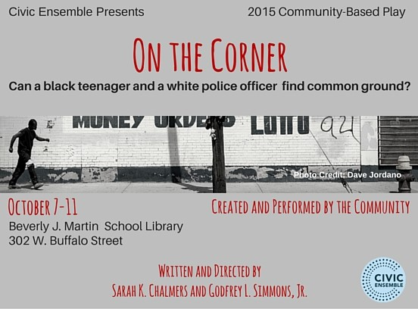

Four Community Foundation funds came together to support two community-based plays over two years; all responded to a single request for funding in our fall, 2013 grant cycle. They were inspired to support the purpose of community-based arts, which is the engagement of the participants in a process of self and group discovery. Ithaca is a community comprised of people from diverse economic and social backgrounds. Civic Ensemble creates an environment where we as a community can examine different points of view without judgment.
In the spring of 2014, they produced Safety, a project that used collaboratively created storytelling to address the divisions in our community with regard to policing and public safety. On the Corner is the second play produced from this grant. Live showings October 7-11, 2015. It follows Julian, an African-American teenager, and the white police officer who detains him, as they travel from the Wall Street slave market of 1690, to a Bronx high school in 1978. When they disagree about the meaning of this history, their journey leads them to the heart of our divided America, and the possibility of a new future.
We celebrate support of these projects through multiple grants from a range of Community Foundation funds: The Tompkins Today and Tomorrow Fund, the Community Enrichment Fund, and two field of interest funds, the Arts and Culture Fund and the Social Justice Fund.

Who may participate in a Community Foundation?
You! Community foundations were originally created and exist today to give everyone the same option that the wealthy have always enjoyed: namely to set aside a sum of money that will yield income in perpetuity for charitable purposes. They can be found in over 800 locations and are sometimes called “every one’s” foundation.

How do Community Foundations spend their money?
Most gifts to community foundations are intended to create permanent funds. The community foundation makes grants from the income from these invested funds each year and preserves the principal amount in perpetuity as the community’s asset.

Who controls a Community Foundation?
Community foundations are governed by local volunteers selected to serve on its board of directors, chosen to represent the community’s best interests and are widely recognized for their service and reputation and integrity as community leaders.

How do Community Foundations make a difference?
Community foundations are conservators of community capital. They often, but not exclusively, focus on those special times when community donors can establish permanent funds. Such events as considering a will or an estate plan, the sale of property, or a business, at times of extraordinary capital gain, or when a perpetual memorial to a loved one seems in order. And, as a service to other non-profits, they frequently hold their designated endowment funds.

Do Community Foundations support a range of interests?
Yes. Community foundations support a broad range of charitable interests and reflect the wishes, needs, and convictions of the entire community. Anyone is welcome to contribute to the work of a community foundation by making contributions which support its operation, and/or by establishing a fund with a particular charitable interest in mind. Over time, as community foundations grow, these collections of community funds reflect the wide variety of interests and needs of donors and the entire community.
Engage in local philanthropy thru your Community Foundation.
Find out how at www.cftompkins.org
Community Foundation of Tompkins County 200 East Buffalo St., Suite 202 Ithaca, NY 14850

