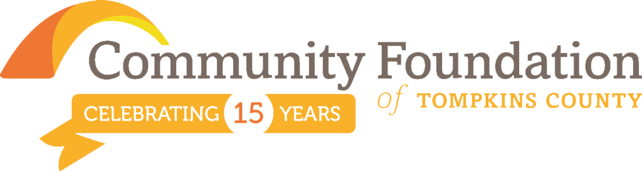

Investing in the Future of Your Community
George Ferrari, CEO, Community Foundation of Tompkins County

Community Foundation grantmaking draws on innovation, collaboration and donor generosity to deliver human impact. How does getting your hands dirty lead to our youth building a more just community? Take a look at the Youth Farm Project and how it uses agriculture to empower a diverse group of young people to become leaders. Your Community Foundation celebrates our support of this program through multiple grants from a variety of funds.

The Youth Farm Project (YFP) is in its sixth season, growing produce on a 10 acre farm on Nelson Road. It uses agriculture as a tool for teaching sustainable methods of growing food, the impact of our current food system on health and the environment, and also its impact on social justice issues concerning unequal access to healthy food. The program empowers a diverse group of young people by teaching communication skills through a strong mentoring model. YFP has become a cornerstone employment placement for area youth from all backgrounds and neighborhoods within our community.

And it gets better; the program earns a portion of its revenue by selling some of its 11,500 lbs. of produce to the Full Plate Farm Collective CSA, BJM Elementary School's Fresh Fruit and Vegetable Snack Program, GIAC, the Ithaca City School District Lunch Program, the LACS lunch program, and the Congo Square Market.

This story—alongside the countless others like it—demonstrates the tremendous impact and unique importance of community foundations in this country. From November 12 to 18, we celebrate Community Foundation Week, our chance to share and reflect on these stories. Though you may not yet know your local community foundation, you’ve likely felt its impact.

That’s because your Community Foundation and more than 750 other community foundations across the country help to bring donors and residents together. The community foundation unites all of our efforts in special ways that will help the places we call home continue to flourish and grow.

During this week your Community Foundation will announce $115,000 of grants in a new collective impact two year grant cycle as well as help to co-sponsor National Philanthropy Day. We remain committed to advance the community conversations on collective impact, on racial equity and on women and poverty.

As we enter the giving season, America’s generosity surges. Millions of people from every background will be looking to give back to the communities that have supported them. They’ll also look to ensure that their heartfelt giving—however they choose to give—will have the most impact. That’s why so many of them will choose to give to a community foundation.

A gift to your local community foundation is really an investment in the future of your community. The funds will go to work immediately supporting vital services, but they will also provide sustained support for years to come. We like to say that community foundations are “here for good.” At your Community Foundation we don’t think about the next election or business cycle, we think about the next generation and the next after that.

That can seem a daunting task, but it’s one that we all share. During Community Foundation Week, I hope you’ll join us in recognizing our collective impact and the difference we can make together.

Community Foundation of Tompkins County awarded 241 grants in the period January 1-September 30, 2015 totaling $1,542,637 in support of the arts & culture, environment, education, health & human services, and other means of community growth. We are celebrating 15 years of philanthropic achievements with more than $8 million dollars in over 2,200 grants.

For more information visit www.cftompkins.org

