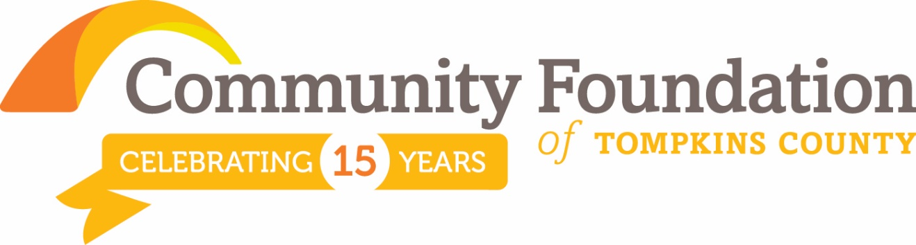
FOR IMMEDIATE RELEASE
For More Information Contact:
Nancy Massicci, Chief Development Officer
607-272-9333
nmassicci@cftompkins.org

Community Foundation Celebrates 15th Anniversary: A Night on the Town Gala
ITHACA, NY NOV. 9 - FOR IMMEDIATE RELEASE
The Community Foundation of Tompkins County celebrated its 15th Anniversary with a SOLD OUT Gala which included a reception, remarks, dinner and dancing on Saturday, November 7 at Celebrations.

The program, titled “Creating Community Connections” included multiple speakers, incorporating visionary, Dan Mansoor, professional advisor, John Hinchcliff, grant review team member, Cate Hackett, grant recipient, Diane Cohen, Finger Lakes ReUse, designated fund, Lansing Community Library, Susie Gutenberger, and donor advisor, Shelley Semmler. In addition, County Representative, Mike Lane, read a proclamation naming November 7, 2015, Community Foundation of Tompkins County Day.
Attendees enjoyed an evening of celebration welcomed by Alan Mathios, Board Chair who recognized past board members in attendance, Peg Hendricks, John Hinchcliff, Linda Madeo and Robin Masson. George Ferrari, CEO, served as emcee.

Thanks to our generous gala corporate sponsors:
Alesco Advisors, LLC
Cornell University
CFCU Community Credit Union
C.S.P. Management
Hancock Estabrook, LLP
Miller Mayer, LLP
Robin Abrahamson Masson, Collaborative Attorney and Mediator
Therm Inc
Triad Foundation, Inc
M&T Bank
Mariette Geldenhuys, Collaborative Attorney and Mediator
Sciarabba Walker & Co., LLP
Strebel Planning Group
Tompkins Trust Company
Plenty of Posies
Alternatives Federal Credit Union
Arnold Printing Corporation
Cayuga Landscape
Chris Gibbons CLU, ChFC Financial Advisor with Northwestern Mutual
Crown Construction
First National Bank of Groton
Gimmee! Coffee
Mansour Jewelers
True Insurance
HOLT Architects
Iron Design
Taitem Engineering PC
Wegmans
Fingerlakes Wealth Management

Community members are invited to drop by our Holiday Open House, December 11, from 10:00 a.m. to 2:00 p.m. to mingle and learn more about the foundation.

The Community Foundation is a non-profit public charity created by and for the people of Tompkins County, making grants to date of more than $1.7 million and growing. The organization accepts gifts and bequests. To learn more about the Community Foundation, please contact Nancy Massicci, Chief Development Officer, 200 E. Buffalo Street, suite 202, Ithaca, NY 14850 nmassicci@cftompkins.org or call 272-9333.

