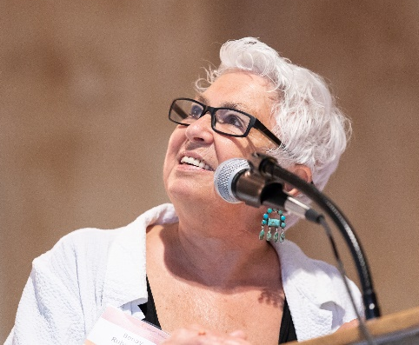
Community Foundation of Tompkins County, May 22, 2018
Annual Celebration: Inspiring Stories, Empowering Community
Community Voices Speaker:
Benay Rubenstein, Founder, College Initiative Upstate (CIU)
(Excerpts from Benay remarks)
I want to begin with the best advice that anyone has given me...........Here it is...
“In life, pay close attention to which doors open with a tap. “
Two years ago, I approached Deb Dietrich, Executive Director of Opportunities, Alternatives & Resources (OAR) with the idea of starting a “Bridge to College” for court-involved and formerly incarcerated people. She immediately said “yes!” and asked if I was ok with setting up shop in a storage closet – I was!
As this chart shows, there is a direct relationship between higher education and recidivism.
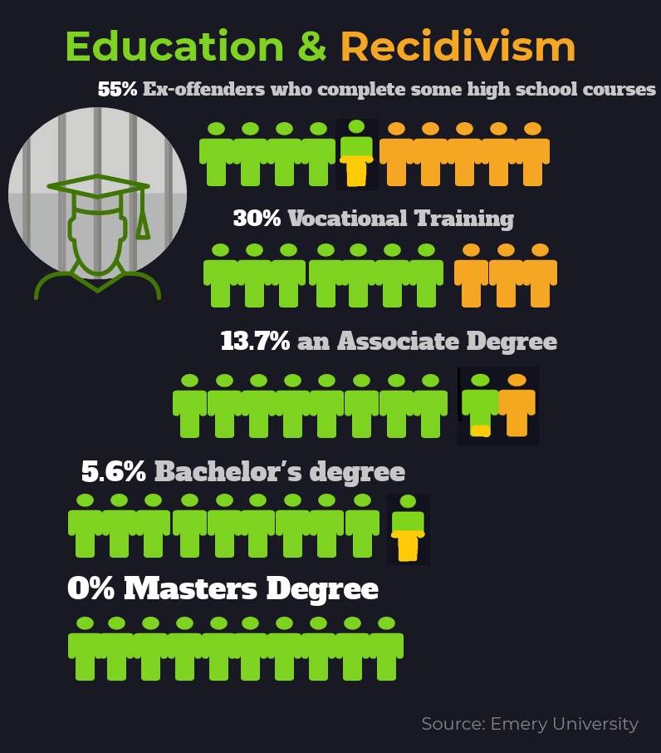

• The national recidivism rate reveals that two out of three people in reentry return to prison within 3 years of release
• With an associate’s degree that lowers to 13. 7 percent
• A bachelor’s degree lowers to 5.6 percent
• And with a master’s recidivism is practically nil
........................
Since opening our doors,
• 45 College Upstate Initiative students successfully completed one or more college semesters
• More than 31 have completed an intensive College Prep Session
• We have strong working partnerships with Tompkins Cortland Community College (TC3), TST-BOCES, the Tompkins County and Ithaca City Court system, Probation, Parole, Tompkins County Jail and more
• Financial support has come through the Tompkins County Legislature and local foundations – including Community Foundation
.............................
Our pivotal question is this:
Who goes to jail/prison and who goes to college?
Most of us here know who goes to college -
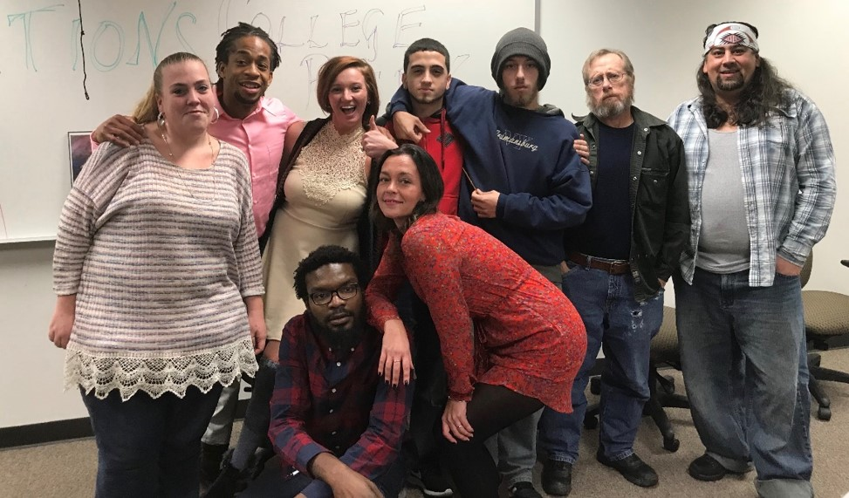
And, most of us also know that who goes to jail follows socioeconomic, class, or racial lines.
However, with College Initiative Upstate’s support, in Tompkins County a person can go to jail and then go to college!
AND, as an Alternative to Incarceration program - some court-involved students can go college instead of going to jail. This may be the only place in our nation where this is an option!
.....................
This Thursday, our first three students will graduate from TC3 with their associate degrees. We know their children and the future of our community will be beneficiaries of their achievements.
Last week, a CIU student, Jodi Anderson, was accepted to Stanford University with a full scholarship. We are now working to have his Parole transferred from NY to California.
Thank you to everyone here for supporting Life, Social Justice, and Miracles!
For more information visit: www.oartompkins.org or www.cftompkins.org

