DonorCentral is the Foundation’s online portal providing you access to your fund(s) information. From here you can view your latest fund balances, get fund statements, make grant recommendations, and review your history.
Getting Started
You will receive an email with a link to the DonorCentral user confirmation page. Following the requirements outlined on this page, set up your password. Once the password is confirmed, the login page appears.
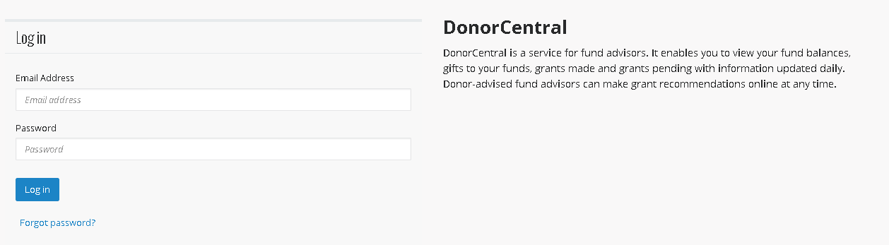
Using your email address and newly created password, log into DonorCentral.
Recommend a Grant
DonorCentral makes it easy for you to recommend a grant from your fund(s). You can replicate previous grants you made or, using the Foundation's nonprofit database, research charities and recommend a new grant.
- From the Dashboard tab, in the View your fund information tile, use the Find field to locate the fund to which you want to add a new grant recommendation. As you type, the application matches your entry to existing funds in the FIMS database.
- Select Recommend a grant. The Grant Recommendation screen appears.
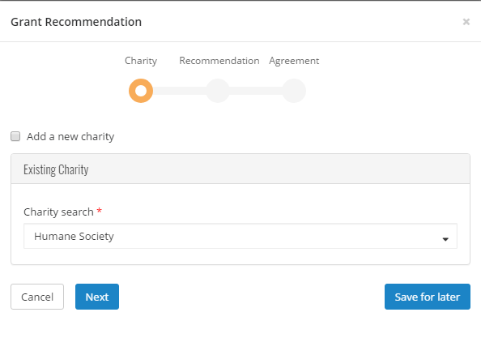
- Select a charity by searching for it in the Charity search field.
If the charity does not exist, check the Add a new charity box to create a new charity.
- Select Next.
- In the Fund section, select the fund you want used for this recommendation. You can keep the fund selected or search for a different fund by typing in the field provided. If you select the Fund anonymous option, the fund is marked anonymous on the Payment Plan tab in FIMS, and when the grant check is printed, instead of having the fund name print on the check stub, “Anonymous Fund” appears. In addition, if you select this option, the information is hidden from other grant funders in DonorCentral.
- In the Grant section, enter the recommended Amount, Program name, Grant purpose, and any Special request. To not display an advisor, select the Advisor anonymous option.
- To recommend a recurring grant, select the Is recurring box, and fill in the Start time, End time, Frequency, and any Notes.
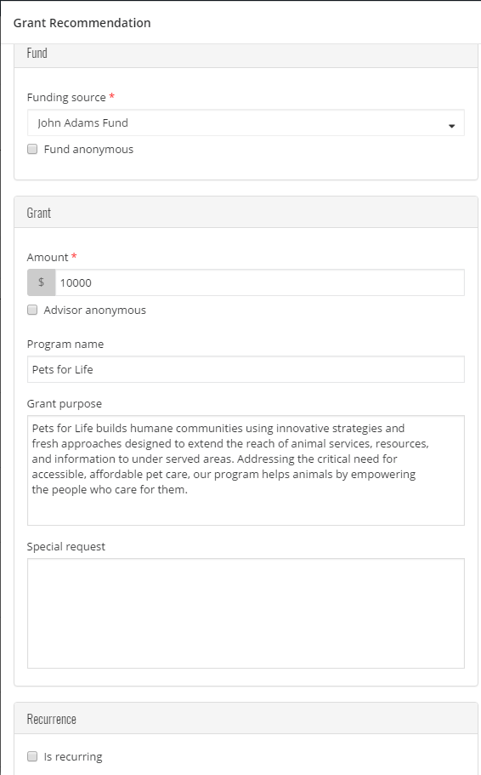
- Select Next.
- Acknowledge the grant recommendation requirements by selecting the I agree box.
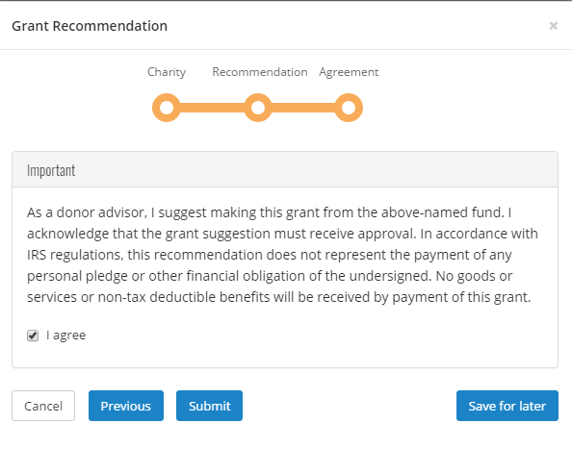
- Select Submit.
If necessary, at any time in the process click Save for Later to store your grant recommendation without submitting. To return later and complete it, look for it in the Submit your saved grant recommendations tile.
View your Fund information
DonorCentral offers easy access to comprehensive information about your fund(s), allowing you to view, print, and email fund statements. To view fund information, you can select either the Fund info tab or the Dashboard tab.
- From the Dashboard, in the Find field in the View your fund information section, enter the name of the fund you want to view. Once it displays, click See more fund information. This takes you to the Fund info tab.
- From the Fund info tab, in the Choose a fund field, start typing the name of the fund. As you type, the system displays funds with matching text. Select the desired fund.
The fund name, description, Spendable balance and other details display. The Period defaults to All, but options for This Month, This Quarter, This Year, or Last Year are also available. Click one of the totals displayed and all related records and details display in the grid below. Hover the mouse cursor over the information bubble to view an explanation of the total.
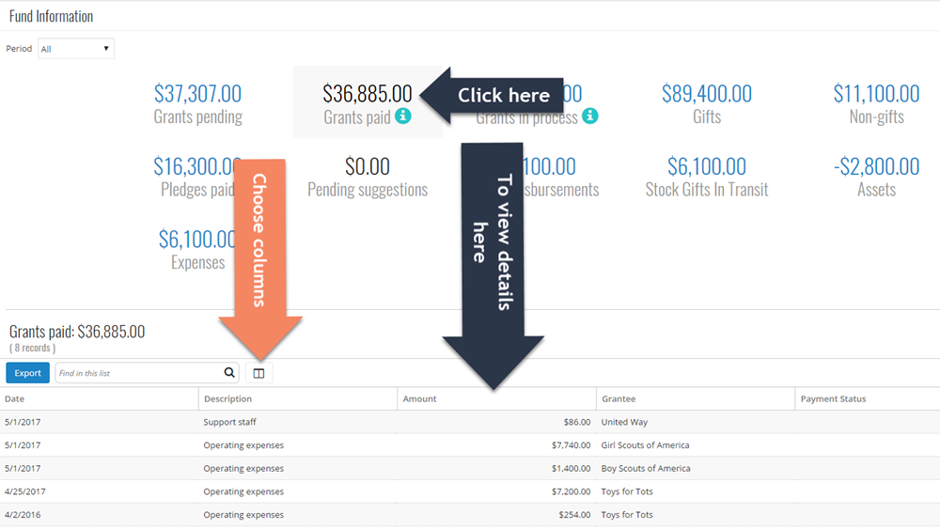
Explore Grant Opportunities
From the Dashboard tab, in the Explore Opportunities tile, locate the opportunity for which you want to recommend a grant. Click Recommend a Grant. The Grant Recommendation screen appears. For information about creating a grant recommendation, see the Recommend a Grant section above.
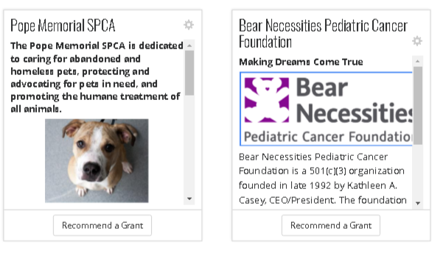

View Grant History
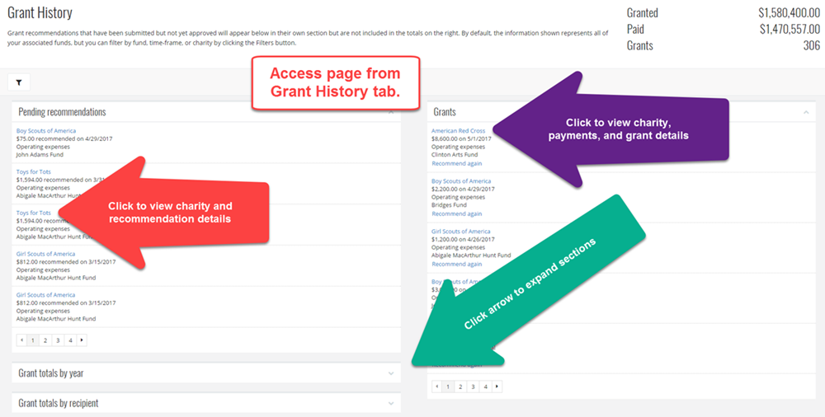
Reset Password
- From the far right-hand side of the application, in the header, click the drop-down menu next "Welcome, <user name>" and select Reset password.
DonorCentral does not limit login attempts; users are not locked out after several attempts.
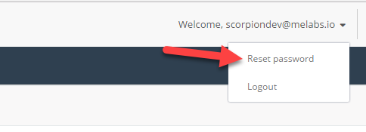
- The Reset password screen appears. Enter the necessary information.
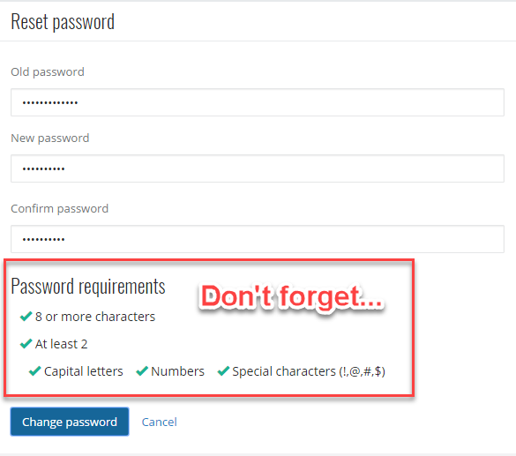
- Select Change password.

