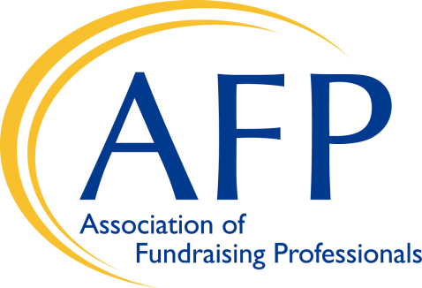

2019 Finger Lakes Chapter

Philanthropy Day Awards
Presented by the Finger Lakes Chapter of the
Association of Fundraising Professionals
In honor of National Philanthropy Day
Presentation Luncheon · November 15, 2019

The Finger Lakes Chapter of the Association of Fundraising Professionals (AFP) is pleased to invite nominations for the following awards for philanthropic leadership in the Finger Lakes region.

The deadline for nominations is: September 15, 2019

Award Categories

Philanthropist of the Year: honors an individual or family that has demonstrated exemplary financial support of and volunteer leadership in the nonprofit sector.

Corporate Philanthropist of the Year: honors an area business – local, national or international – that has demonstrated exemplary financial and/or in-kind support and volunteer leadership in the nonprofit sector.

Volunteer Fundraiser of the Year: honors an individual or family that has demonstrated exemplary volunteer leadership in the nonprofit sector.

Outstanding Professional Achievement in Nonprofit Leadership: honors an individual who has demonstrated exemplary commitment, professionalism and leadership throughout the course of a career.

The Philanthropy Day Awards are presented in conjunction with the nationwide observance of National Philanthropy Day. The Finger Lakes Chapter of AFP will honor recipients at the National Philanthropy Day luncheon on Friday, November 15, 2019 at Emerson Suites, Ithaca College. The honoree must be present to receive the award.

Guidelines for Submitting Nominations

Nominees must reside or conduct business in Broome, Cayuga, Chemung, Chenango, Cortland, Livingston, Monroe, Ontario, Schuyler, Seneca, Steuben, Tioga, Tompkins, Wayne and/or Yates Counties in the Finger Lakes Region of Upstate New York.

Nominations may be made by a single or multiple individuals or nonprofits. They are limited to the online nomination form, plus appendices (please limit appendices to the most relevant items), and should demonstrate the broad range of the nominee’s community involvement. Although posthumous nominations are not encouraged, they will be considered for recently deceased individuals. Please email appendices to online nominations to Amy LeViere

Selection Process
The Executive Committee of AFP’s Finger Lakes Chapter Board of Directors will select all Philanthropy Day Award recipients. In any given year, the Committee may elect not to make a particular award. Names of Philanthropy Day Award recipients will be announced to nominators in early October.

Criteria for Selection

Philanthropist of the Year
Nominations will be accepted for individuals or families who have modeled philanthropic leadership:

- Through sustained leadership-level giving that has furthered the mission of one of more
Nonprofit organizations in the Finger Lakes region and benefited the populations served by
these organizations.

- By encouraging and motivating others to make precedent-setting gifts and assume volunteer
fundraising leadership roles.

- By demonstrating innovative approaches to nonprofit or institutional advancement.

Corporate Philanthropist of the Year
Nominations will be accepted for any business – local, national or international – that has modeled philanthropic leadership:

- Through sustained leadership-level giving that has furthered the mission of one of more
nonprofit organizations in the Finger Lakes region and benefited the populations served
by these organizations.

- By encouraging and motivating others, including employees, to make precedent-setting
gifts and assume volunteer fundraising leadership roles.

- By demonstrating innovative approaches to social or institutional advancement challenges.

Volunteer Fundraiser of the Year
Nominations will be accepted for individuals or families who have modeled exceptional volunteer fundraising and leadership:

- Through sustained leadership-level fundraising that has furthered the mission of one or more nonprofit organizations in the Finger Lakes region and benefited the populations served by these organizations

- By encouraging and motivating others to make significant gifts and/or to participate in the mission and programs of community nonprofits

Outstanding Professional Achievement in Nonprofit Leadership
Nominations will be accepted for individuals who have modeled nonprofit leadership through:

- Demonstrated effective and creative leadership in the nonprofit world, with a proven track record
of significant achievement over a period of many years

- Advancing worthy causes and the nonprofit profession in general, including activities to support and mentor others, and continued professional development

- A commitment to the nonprofit profession, philanthropy, and volunteer service demonstrated by personal as well as professional financial support for nonprofit organizations

Nomination Submission

To be considered, nominations must be received by September 15, 2019
- late entries are not accepted.

Submit a nomination:

- ONLINE: CLICK HERE

If you have questions please email Amy LeViere aleviere@cftompkins.org
or call 607-272-9333

