|  |  |  |  |  |
| --- | --- | --- | --- | --- |
|  |  | |  | | --- | | Field of Interest Fund  Summer 2016 | |  | |
|  |  |  |
| the ripple effect: one action, many results |  | community impact |

### The Ripple Effect: uncovering needs, expanding funding, magnified results

At the Community Foundation’s Annual Meeting panelist, Risa Mish, Cornell University’s Johnson School faculty member, shared how she learned about the stark reality, that some women in our community did not have the most basic necessities and undergarments to dress for a job interview. Having attended the annual Women’s Fund Luncheon and hearing one of the stories shared by Dammi Herath, Executive Director, at the Women’s Opportunity Center, Risa expanded her giving, making an additional gift to the Women’s Opportunity Center.

|  |  |
| --- | --- |
|  |  |

39%

**Gender and Poverty**

39% of Tompkins County families with children, who have a female head of household, live in poverty.

Through last year’s grant cycle, the Women’s Opportunity Center received $2,250 from the **Women’s Fund, Rachel J. Siegel Fund** and **21 Goodwill Street Fund**. This allowed 5 participants a weekly stipend while they completed a 6 week “On the Job” training program. Participants have no work history or work experience and are having difficulty competing in the job market with those who do. This grant provided them with income while not losing other necessary support services through the Department of Social Services.

*Come meet other active donors, staff and Board members through your Community Foundation, call us, or visit www.cftompkins.org*

The 2016 Women’s Fund Grant Cycle awarded 17 grants to 12 organizations totaling a record $32,445 from the Women’s Fund, Crime Victims Fund, and 6 Donor Advised Funds.

2016 Women’s Fund Grant Cycle priority areas:

* promote educational, economic, social and political equality for women
* enable women to achieve economic self-sufficiency
* insure that women have necessary healthcare resources

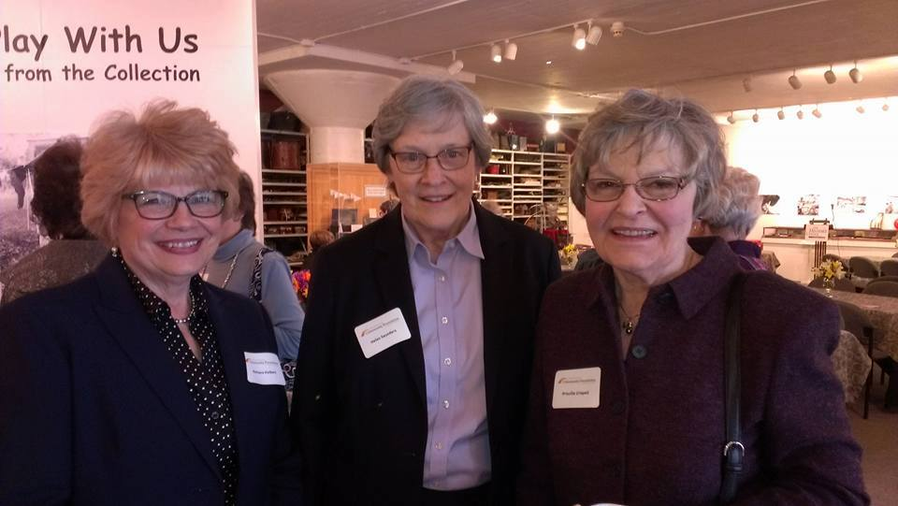

Thank you to our many volunteers

From serving on grant review teams, office filing, board service, committee work, and much more; you are ambassadors of community philanthropy.

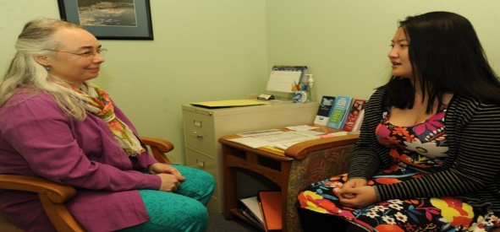

Promoting Women’s Health

Ithaca Health Alliance, advocating and providing health care and services for women of all ages.

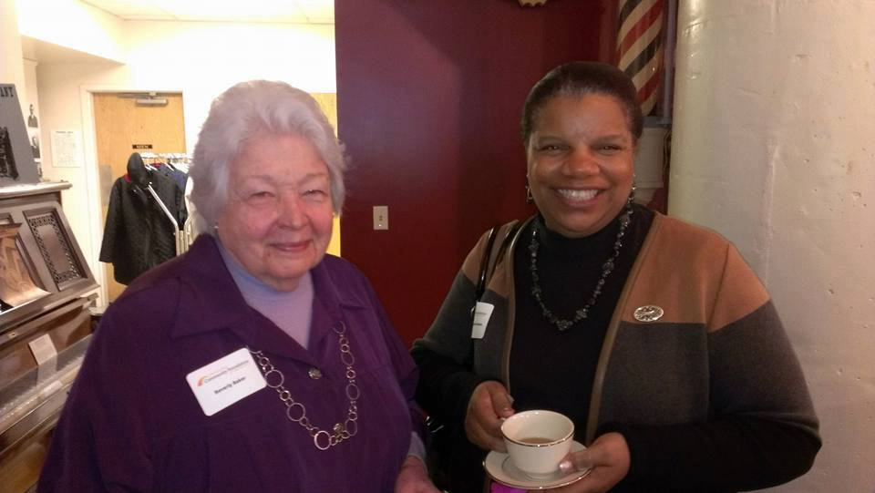

Women’s Fund Tea Honorees

Beverly Baker and Schelley Michell-Nunn in attendance at the annual Tea.



## By The Numbers (6/30/16)

$ 268,000 Women’s Fund Assets

$ 261,000 Endowed Assets

$ 7,000 Expendable Assets

Women’s Fund Advisory Committee

Angela Sullivan, Ann Mathews, Annie Wall, Carol Travis, Carrie Regenstein, Elsa Hyde, Jan Hertel, Jill Burlington, Nancy Schuler, Stephanie Bailey, Suzanne Brache, Suzanne Smith Jablonski

We serve as a catalyst; we partner with local agencies; we support community needs; and we honor local volunteers.

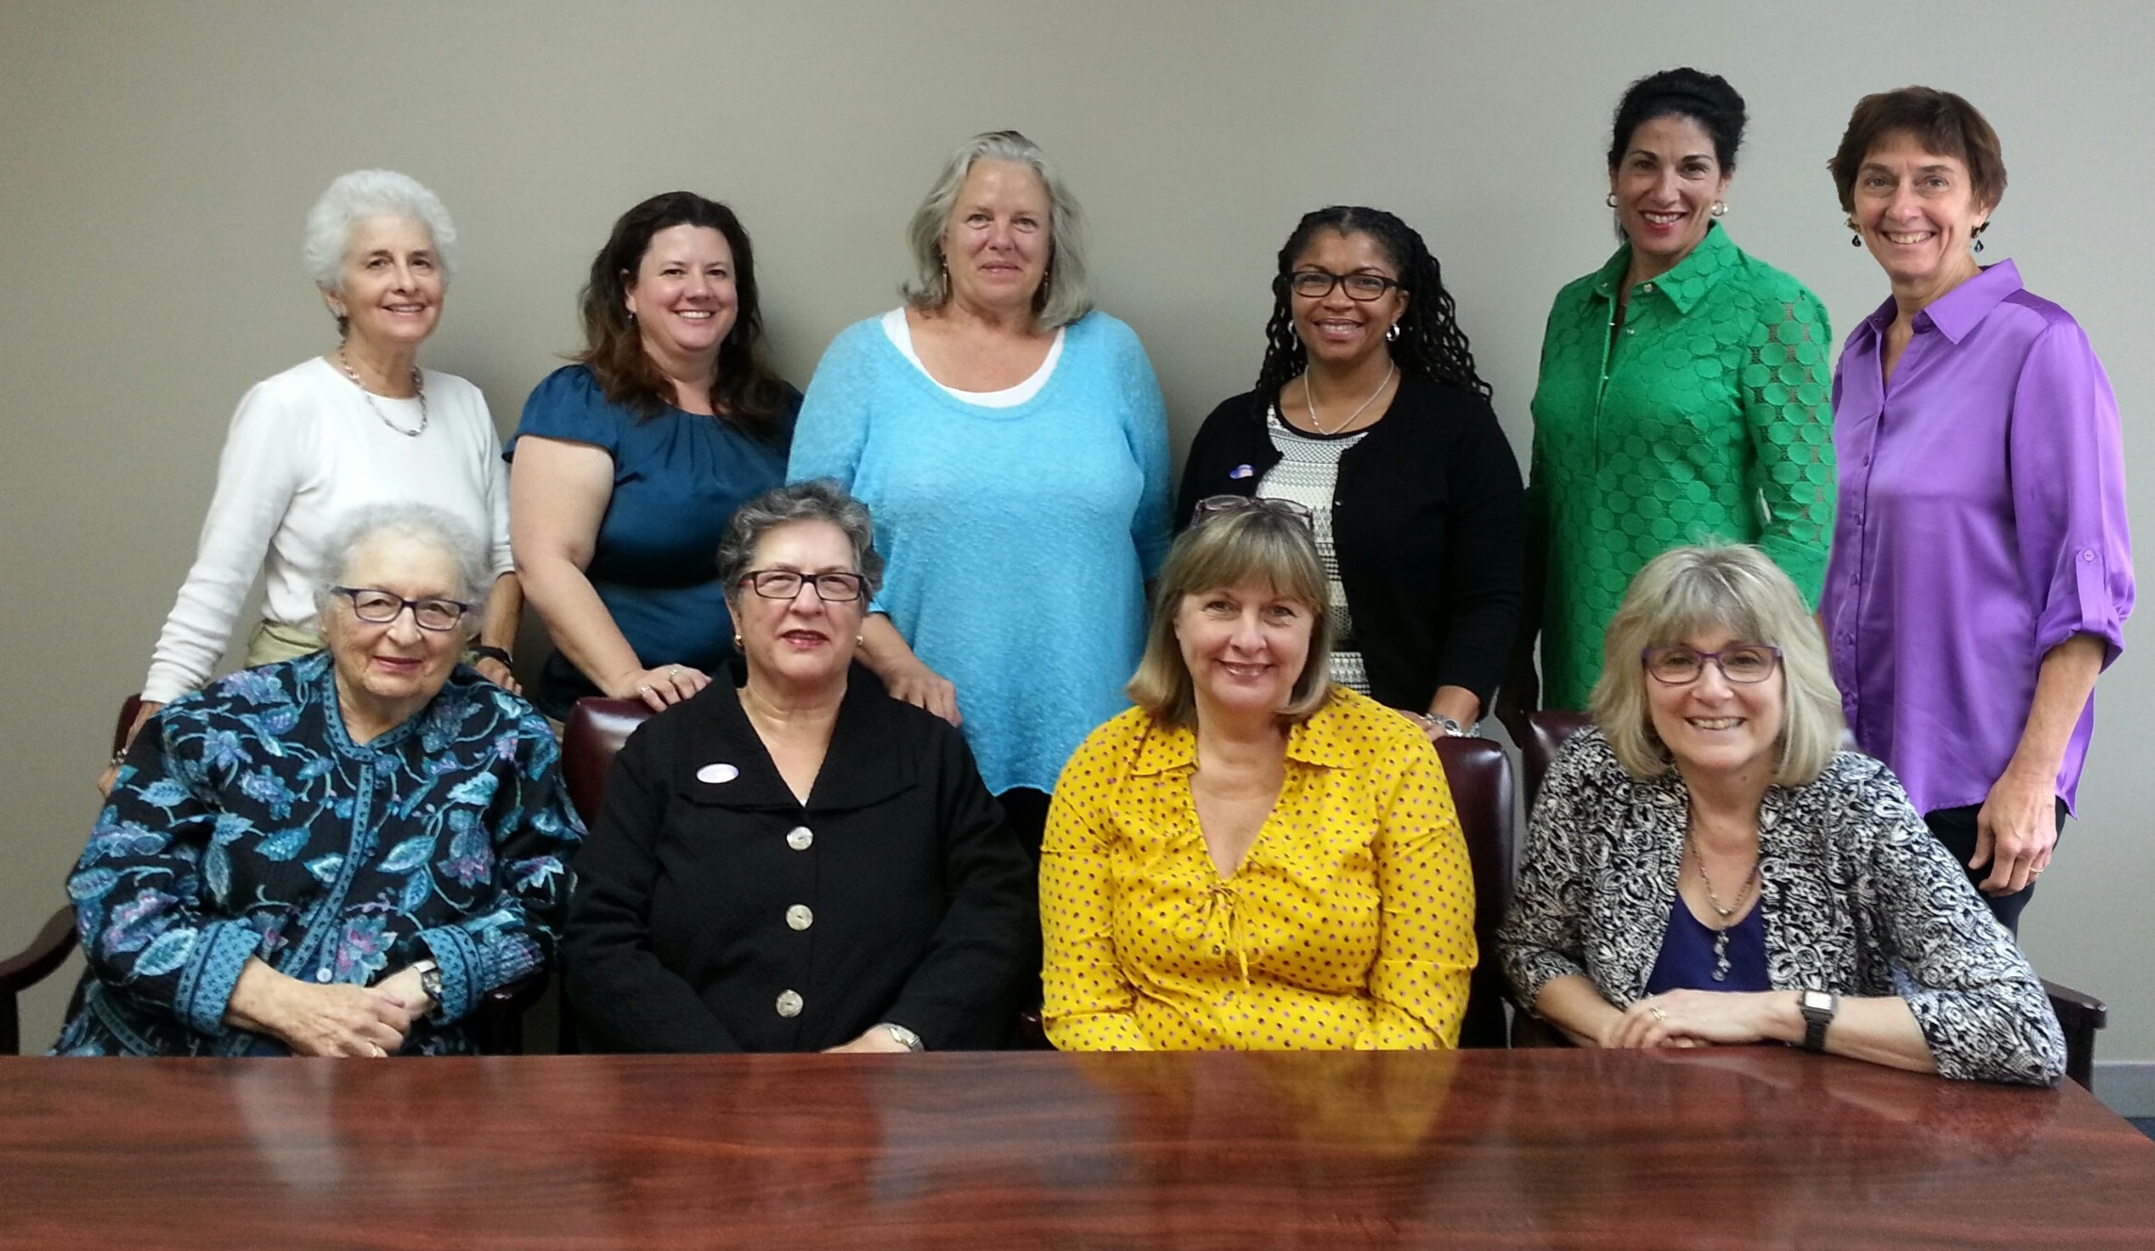

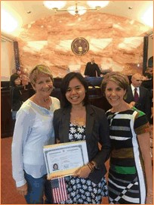

Community Impact

Recent grant funds a pathway to citizenship for the Immigrant Services Program through Catholic Charities assisting low income women applying for work authorization and citizenship.

The Community Foundation enables everyone to be a philanthropist.

|  |  |
| --- | --- |
|  |  |

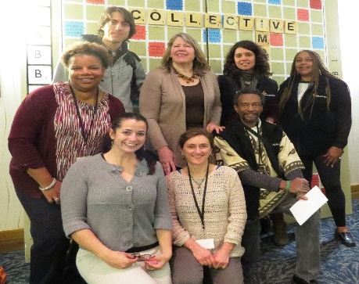

YOUR GIFTS MAKE THIS POSSIBLE

FOR MORE INFORMATION, VISIT: **www.cftompkins.org/giving/our-funds/womens-fund**

Since inception, the Women’s Fund has made grants totaling more than $100,000; the annual Women’s Fund Grant Cycle leverages additional funding, expanding the impact of many important programs in our community.



**CATALIZING AND CONVENING**

**Past years’ themes and topics:**

**Spring Annual Lunches held in March**

**2016** Bridges: A Journey Reflections on My Life’s Work in Senior Care

**2015** Stepping Out of the Shadows: Embracing New Leaders, New Voices

**2014** Women Donors: Philanthropy’s Untapped Resource

**Fall Gatherings held in November**

**2015** Women and Poverty Demographic Data

**2014** Serving Women Veterans: Community Supports

**2013** From Mumbai to Ithaca: A Passion for Gender Justice

I