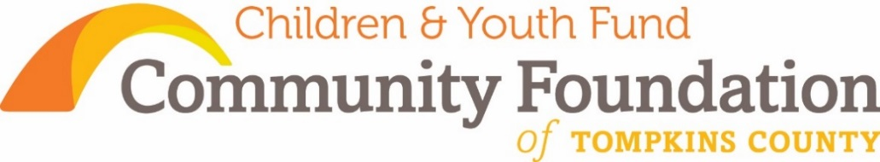

***Supporting Children and Youth to Thrive as Cancer Touches their Lives***

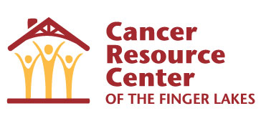The Children & Youth Fund of Community Foundation has a long history of supporting young people as they face cancer in their lives. **A grant to the Cancer Resource Center of the Finger Lakes in 2015 for the CRC Cares About Kids program has supported families that have a parent who has been diagnosed with cancer.** Trained volunteers provide a comfortable environment where children can talk about their parent’s cancer. This trained childcare also allows parents to attend and benefit from the support groups offered. Recreational events are provided to allow children to meet others whose families are facing similar challenges. Information has been distributed throughout Tompkins County School Districts and at Cayuga Medical Center offering informational resources for youth. Outreach to schools and parents in particular has laid a foundation for further development of the CRC Cares about Kids Program.

In 2016, the Children & Youth Fund supported Camp Kesem at Cornell University. **Camp Kesem is a nationwide community driven by passionate college student leaders, that supports children through and beyond their parent’s cancer**. By providing a free week of summer camp and yearlong programming, Camp Kesem recognizes and embraces the often-overlooked population of children touched by a parent’s cancer by providing innovative, fun-filled programs that foster a lasting community.

“Camp Kesem taught me to be a more patient and a kind person. It helped me remember that I’m not the only one out there with this burden to carry”. – Camp Kesem Camper

https://media.licdn.com/media/p/7/000/23b/298/30bd0c1.png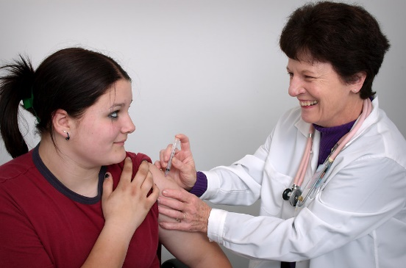  **This fund also supported Planned Parenthood of the Southern Finger Lakes to continue to offer HPV and cervical cancer vaccines to uninsured girls in Tompkins County, thereby preserving their current and future health.** This FDA-approved vaccine helps to prevent human papillomavirus, often the root cause of cervical cancer. Protecting the health of our children affects not only their welfare and futures, but has an impact on our community as a whole. Girls who get preventative care, treatment, and related information are more likely to stay well and remain in school.

Community Foundation’s Children & Youth Fund is dedicated to the needs of young people in Tompkins County. Support of these valuable programs is assuring good health in our children and youth, today and tomorrow.