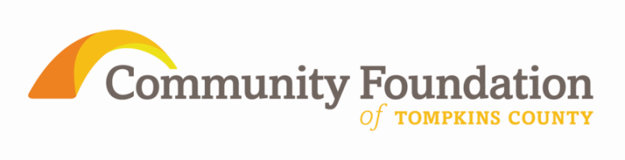
FOR IMMEDIATE RELEASE
For More Information Contact:
George Ferrari
607-272-9333
gferrari@communityfoundationoftc.org

Community Foundation of Tompkins County Awards 2nd Annual

Rosen Library Fund Grants
ITHACA, NY March 30 - FOR IMMEDIATE RELEASE

A second year of support for youth reading and library use is about to be delivered to our region thanks to the endowed Bernard Carl and Shirley Rosen Library Fund of the Community Foundation. The 2012 review process resulted in 19 grants totaling nearly $75,000 to 14 libraries in the Finger Lakes Library System serving Cayuga, Cortland, Tioga, Tompkins and Seneca counties. These grants are made possible thanks to a bequest of nearly $3 million from the estate of Dr. Bernard Rosen.

Dr. Rosen documented his desire for the fund with specific language in his will. “The mission I intend for the Fund is to promote genuine intellectual curiosity and a lifelong love of reading and learning.” The specific purpose of the Bernard Carl and Shirley Rosen Library Fund is “to promote greater and easier access by youth to local libraries.”

Community Foundation Executive Director George Ferrari commented “We are so fortunate to have assembled a team with expertise in education, youth services, and libraries to review applications and to recommend grants to the Fund’s donor advisor, Mark Rosen, Dr Rosen’s nephew.”

The Rosen Library Fund grants will be of timely use as most libraries are gearing up for summer youth programs.

The Community Foundation manages assets of more than $8.2 million and since its inception in 2000 has facilitated more than $3.6 million in awards in the Tompkins County community from over 1,200 individual grants. Information about the mission and operations of the Community Foundation, and guidance regarding how to invest in the community as a Foundation donor, is available at www.cftompkins.org.

Library | Project | Grant Amount
Cortland Free Library | Eager to Read E-Readers - Nook Book Book Club | $ 1,363.78
Ulysses Philomathic Library | Teen & Tween Reading Riot! | $ 8,000.00
Waterloo Library | Kids & Books | $ 4,608.00
Waterloo Library | Teens: Express Yourself | $ 4,050.00
Waterloo Library | Reading Buddies | $ 4,160.00
Southworth Library Association | Family Storytimes at the library | $ 3,420.00
Interlaken Public Library | Dinosaur Invasion | $ 1,250.00
Lang Memorial Library | Science On the Go | $ 706.79
Lansing Community Library | Lansing Book Buddies | $ 2,760.00
Aurora Free Library and Hazard Library | Every Child Ready to Read at Hazard & Aurora Libraries | $ 10,900.00
Seneca Falls Library | Use Your Words! Encouraging a Love of Letters in Babies, Kids & Teens | $ 2,850.00
Lodi Whittier Library | 2012 Summer Reading Program | $ 1,600.00
Newfield Public Library | Camp Summer Reading Program | $ 2,000.00
Newfield Public Library | books for distribution to youth | $ 1,620.00
Phillips Free Library | Fantastical Worlds @ Your Library | $ 9,185.00
Phillips Free Library | books for distribution to youth | $ 450.00
Edith B. Ford Memorial Library | "Telling Tales" Storytelling Camp | $ 894.00
Edith B. Ford Memorial Library | "Storming the Castle: Learning to Learn at the Library for Youth Ages 5-10" | $ 2,000.00
Edith B. Ford Memorial Library | LIFT (Libraries for Teens) | $ 13,000.00

