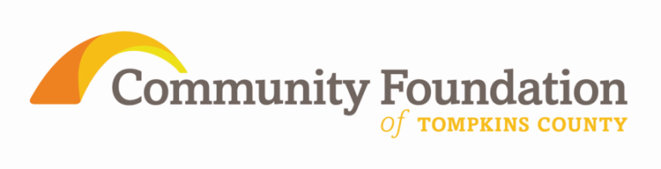
FOR IMMEDIATE RELEASE
For More Information Contact:
George Ferrari
607-272-9333
gferrari@cftompkins.org

Community Foundation of Tompkins County Participates in National Effort to Highlight Local Impact of Philanthropy

During the week of November 12-18, 2012, Community Foundation of Tompkins County will join more than 700 community foundations across America for Community Foundation Week. As part of the celebration, Community Foundation will release news on November 13 of more than $50,000 of grants to be awarded in its Fall 2012 Excellence in the New Economic Era grant cycle.

Observed for more than 20 years, the special week has raised awareness about the increasingly important role of this unique type of philanthropic organization. Community foundations are independent place-based public charities which foster local collaboration and innovation to address persistent civic and economic challenges.

“Community foundations are dedicated to helping everyone in a region by serving donors and by supporting non-profit agencies. We solve problems and improve futures with powerful impact,” said George Ferrari, Executive Director “In a down economy, with limited funding and a growing need for services to help families in need, we all must be more determined to match resources with philanthropic goals resulting in a constantly improving quality of life in Tompkins County.” Donors, often with the help of their professional advisors, create gift plans that achieve their philanthropic passions, meet diverse economic situations, and maximize their tax deductions. At anytime, anyone may make a donation of any amount into any fund at the Community Foundation.

Community foundations’ tools are not limited to grant making but also go beyond solely financial resources to include the collection and analysis of information. They play a key role in identifying and solving the most challenging problems in a community. Ferrari commented “The Transfer of Wealth Study we commissioned recognizes the opportunity and importance of keeping local resources local. This year we also completed Listening Learning Sessions in all eight of our rural communities. What we learned shapes our grant cycles and continues to build relationships across the county. This September, over 45 local non-profits applied for our 2012 Fall grant cycle.”

Community foundations represent one of the fastest-growing forms of philanthropy. Every state in the United States is home to at least one community foundation—large and small, urban and rural—that is advancing solutions to a wide range of social issues. The 2011 Columbus Survey found that despite the recession, giving by the nation’s 100 largest community foundations actually increased slightly in 2010 to $3.7 billion and exceeded pre-recession levels seen in 2006 and 2007.

The twelve year old Community Foundation of Tompkins County, recently re-confirmed in compliance with the Council on Foundations’ National Standards for another five years, has awarded more than $3.8 million in over 1,300 grants since its inception in 2000.

