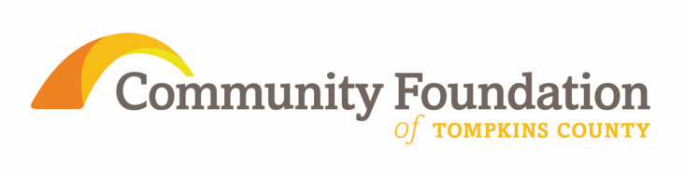

Community Foundation Awards

Excellence in the New Economic Era Grants

ITHACA, NY NOV 16 - FOR IMMEDIATE RELEASE

The Community Foundation of Tompkins County is pleased to announce 41 grants to 28 organizations and municipalities totaling over $87,000 targeted to build and strengthen programs which have suffered funding cuts as well as to build capacity to work more efficiently and more effectively. The majority of grants are from the Tompkins Today and Tomorrow Fund with additional support from donor advised and field of interest funds of the Community Foundation. For the first time individual donors provided initial contributions to increase the grant pool at the start of the process with additional support from the Park Foundation.

Awards by grant objectives

Support for a strong program with demonstrable outcomes that has experienced a reduction of funding since 2008
- Child Development Council for developmental assessments
- Unity House for purchase of equipment to support residents
- Better Housing for Tompkins County for emergency home repair materials
- Alternatives Venture Fund for the Volunteer Income Tax Assistance program
- Planned Parenthood of the Southern Finger Lakes for cervical cancer prevention vaccine for uninsured girls
- Cornell Cooperative Extension of Tompkins County for Caroline youth services, Lansing youth services, and for 4-H Urban Outreach
- Catholic Charities of Tompkins/Tioga for a job developer in the Immigrant Services program and a second grant for utility assistance
- Southside Community Center for nutrition and hot food program
- Ithaca Health Alliance for the Ithaca Free Clinic
- Town of Ulysses for the youth employment program
- Foodnet Meals on Wheels for menu improvement

Capacity Building for operational or strategic planning, board or staff development, or collaboration/restructuring
- Suicide Prevention & Crisis Service for crisis line staff professionalization
- Cancer Resource Center of the Finger Lakes for development resources
- Finger Lakes ReUse for upgrade and expansion of materials tracking system
- Historic Ithaca to qualify as a community based development organization for IURA funding
- Human Services Coalition for 2-1-1 database enhancement
- State Theatre for a digital projector to expand revenue generating programs
- Cornell Cooperative Extension of Tompkins County for PEAKS fundraising tool and a second grant for fundraising planning for Primitive Pursuits
- New Roots Charter School for required strategic planning
- Family & Children’s Service for development restructuring
- Ithaca Health Alliance for Ithaca Health Fund
- National Alliance on Mental Illness, Finger Lakes for strategic planning
- Tompkins County Public Library Foundation for board and staff development
- Community Arts Partnership for an expansion of the Ticket Center

###

Information about the mission and operations of the Community Foundation, and guidance regarding how to invest in the community as a Foundation donor, is available at www.cftompkins.org

