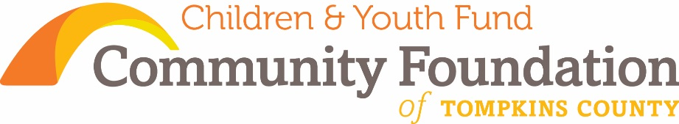
What We Do By the Numbers – 4Q 2015
FIELD OF INTEREST FUND
[Cite your source here.]

Children & Youth Fund

Consistent with the Community Foundation’s mission
“to improve the quality of life in Tompkins County
by inspiring and supporting enduring philanthropy”

The Children & Youth Fund was created to
“promote the healthy development of children and youth in ways that complement existing services.”

Children & Youth Fund of the Community Foundation
From fund inception: August 2001 – 2015
Total amount Granted: $ 63,658
Number of Grants: 24

These grants represent the interests and priorities of the grant making strategy of the Children & Youth Fund Advisory Committee and the Community Foundation’s Board of Directors.

Grant Areas | % of  $ | $ Area  Amount
Afterschool and summer programs | 10% | $ 6,163
Childcare and early start programs | 43% | $27,600
Education, reading, and learning | 18% | $11,315
Health and mental health concerns | 12% | $ 7,600
Youth employment | 17% | $10,980
Total |  | $63,658

Community Foundation of Tompkins County
Status: 501(c)3 public charity

Additional details, information, and reports at: www.cftompkins.org or call 607-272-9333
200 E. Buffalo Street, Suite 202, Ithaca, NY 14850

Community Foundation of Tompkins County confirmed in compliance with
National Standards for
U.S. Community Foundations

Assets (12/31/15)

$ 104,600 Children & Youth Fund assets
$ 94,100 endowed assets
$ 10,500 expendable assets
________________________________________
Return on Portfolio Investments
-2.70% 2015 return
5.41% 2014 return
18.38% 2013 return
6.68% 3 yr. return (annualized)
6.56% 5 yr. return (annualized)
________________________________________
Gifts Received
 | 2015 | 2014 | 2013
$ | $ 52,400 | $ 38,800 | $ 36,400
# | 49 | 26 | 39
________________________________________
Strategy of the Children & Youth Fund
- We fund programs, services, and agencies that serve children and youth.

- We build our endowment, growing a permanent community resource, while making annual grants aligned with the priority areas of the fund and in response to local needs.

- We promote conversations, connections, and philanthropy education around issues affecting children and youth in our communities.

“Nothing you do for children is ever wasted.”
~ Garrison Keillor
2015 CHALLENGE
Grant IMPACT Snapshot
Your community: building it better together
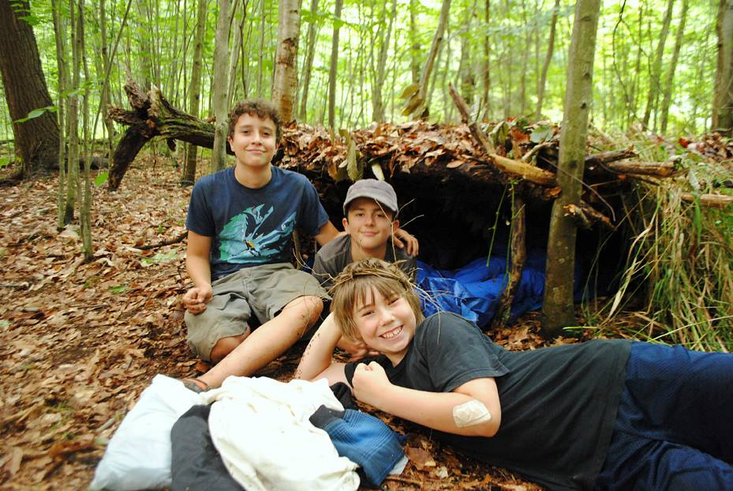
Primitive Pursuits, summer 2013
Lansing Youth Services was able to continue its Primitive Pursuits program due to a grant from the Children & Youth Fund in response to the Community Foundation's Fall Grant Cycle, "Excellence in the New Economic Era". 21 Lansing Middle School students participated in this growing program of Cornell Cooperative Extension of Tompkins County. Students learned life and survival skills, risk taking in a safe atmosphere, and gained an increased awareness and knowledge of the natural world. Students gained a strong sense of belonging and increased their self-confidence in the face of new challenges in the outdoors. The Community Foundation is pleased to support this growing program in our community!

Endowment Goal: $100,000
________________________________________

- Cornerstone Endowment Donor
Donors giving $5,000 and above will receive this special permanent recognition until the Fund reaches $100,000, at which time the recognition of Cornerstone Donor will be retired and cease to be available to subsequent donors.
- Endowment Founder
Donors giving $1,000 and above will receive this special permanent recognition until the Fund reaches $100,000, at which time the recognition of Founder will be retired and cease to be available to subsequent donors.
- Patron
Donors making an endowment gift of $500-$999 will be recognized as a Patron of the Children & Youth Fund.
- Supporter
Donors making an endowment gift of under $500 will be recognized as a Supporter of the Children & Youth Fund.
From our fund’s first donor: “Our possibilities, our future, our children and youth”

By Helen Saunders
After much discussion at the incorporating board, the needs of our community’s children and youth were selected as the focus of the Community Foundation’s first Field of Interest Fund, started in 2001. We appreciated the power and the compassion of helping youth attain their highest level of achievement. Part of the thinking was that helping this early population would hopefully lead to less funding needed later in life to correct the problems that neglecting children would cause. I made the first gift into the Children & Youth Fund in 2001 and continue with a monthly recurring gift. Grants have been made from the Children & Youth Fund annually, beginning in 2008.

